Advance CSS and SASS

Section 2

6. building the header

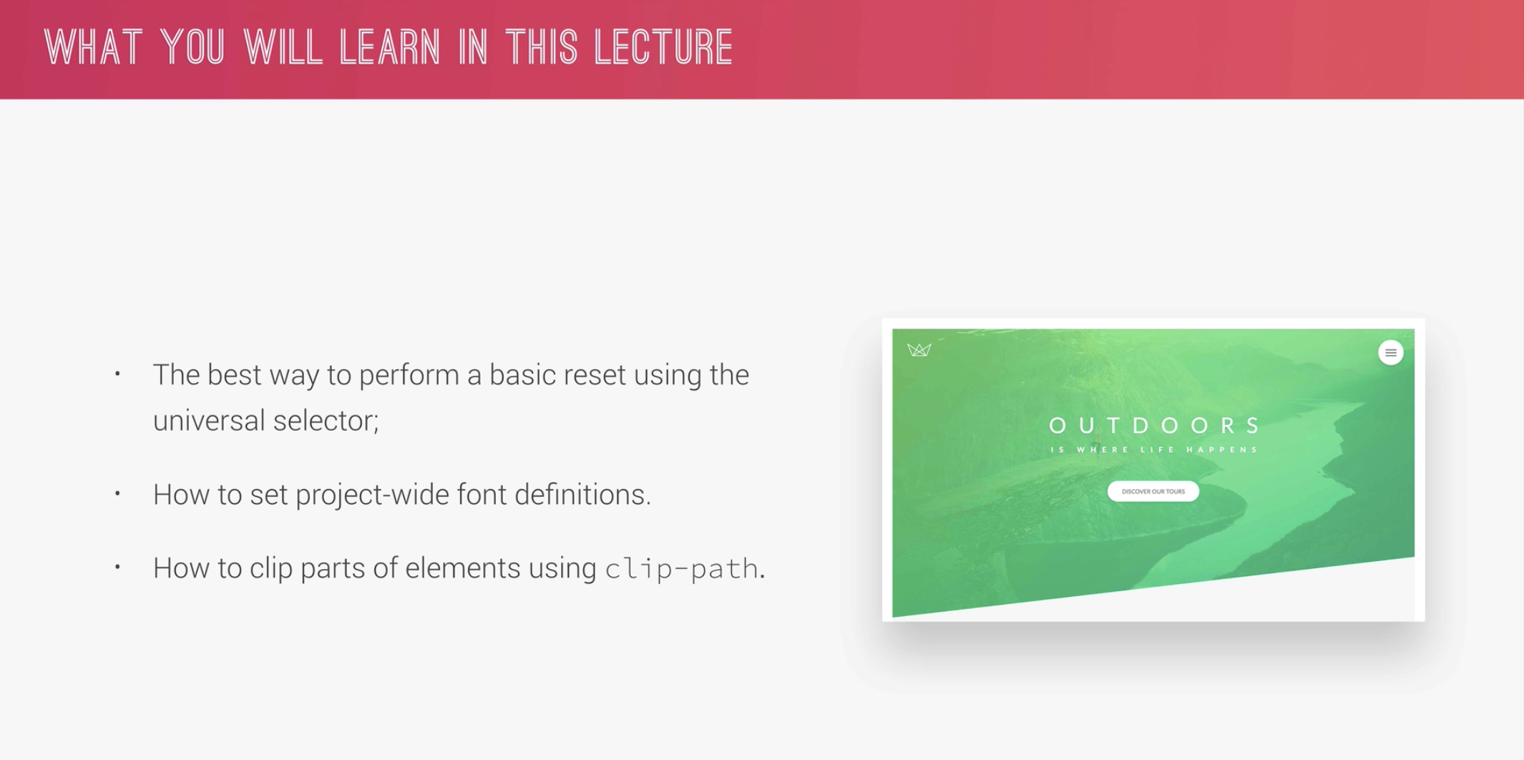 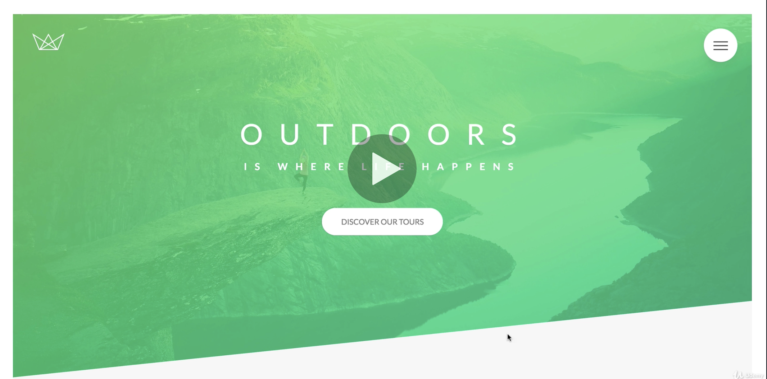

* Basic reset in CSS – it will make every browser render the same way:

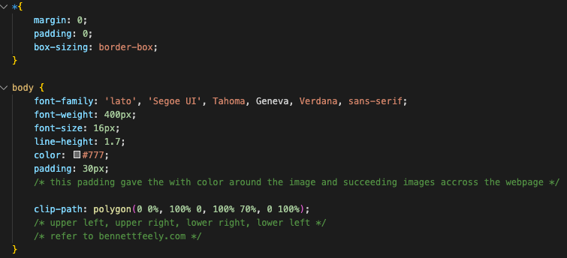

* The header background was defined in css

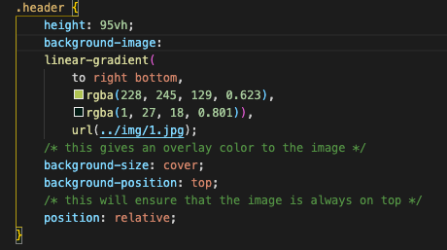

7. building the header Part 2

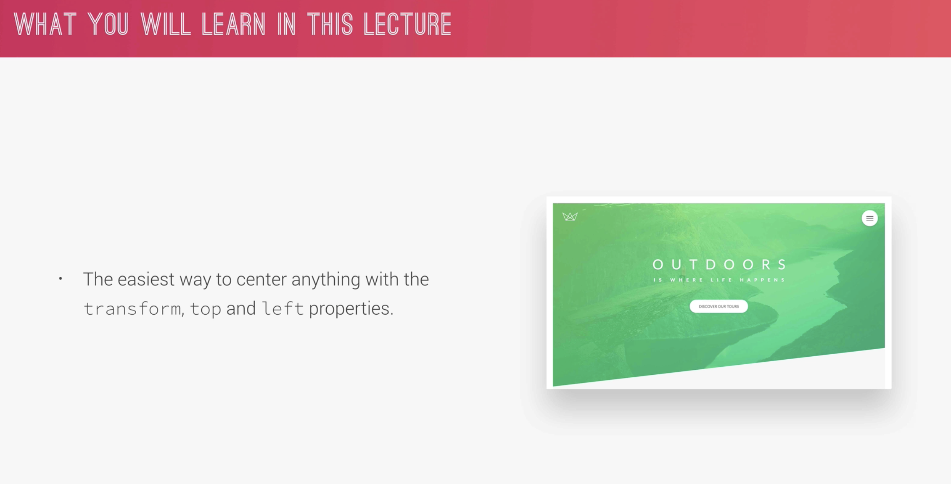

Final outcome of the chapter



Creating the logo box and styling it.

* The html for the header

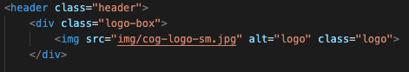

* Top and left 40px absolute is with relative from the parent element header. That’s why header was given a position of relative.

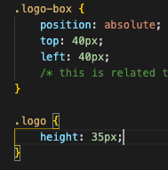

* Create and style the headings (main and sub texts). Here we can see another way to utilize the h tags. Just know that multiple spans can be put inside it and style differently
* Display: block; put the .heading-primary-sub below the .main
* Text-transform is another method learned.

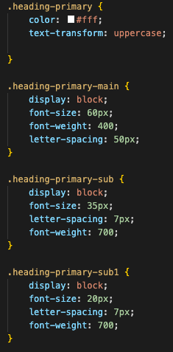

* The transform: translate (-50%, -50%) is with respect to element itself. The top and left are with respect to the parent element which is the header

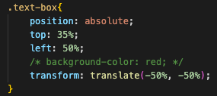

8. Creating cool CSS animations

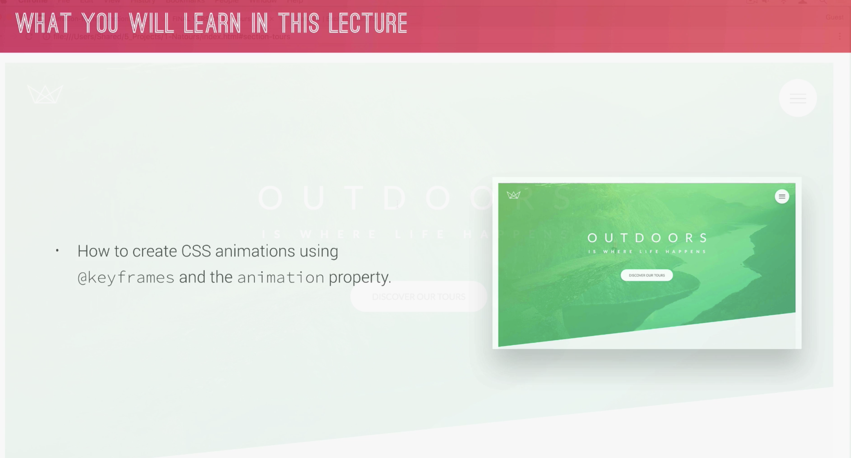

* use of the @keyframes, this is how do we want to look an element during animation.
* Duration is 0% to 100% can do animation in between this period.
* Opacity 0 is invisible.
* Transform: translate (), defines the x and y location of the element on the start and end of animation.
* It’s important to assign an animation name after calling @keyfames. Ensure to call the animation name in the element and do some animation.
* Remember: animation is defined in each element
* Remember: movement and duration is defined in each @keyframes
* Backface-visibility: hidden; is to correct those unknown source of shaking

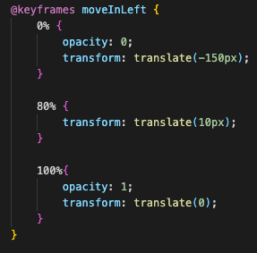 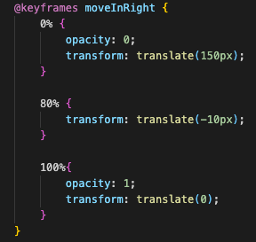 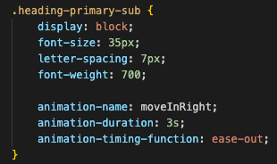

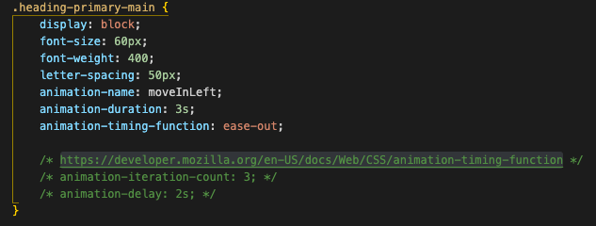 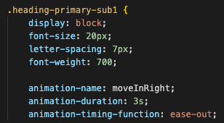

9. Building a complex animated button part 1

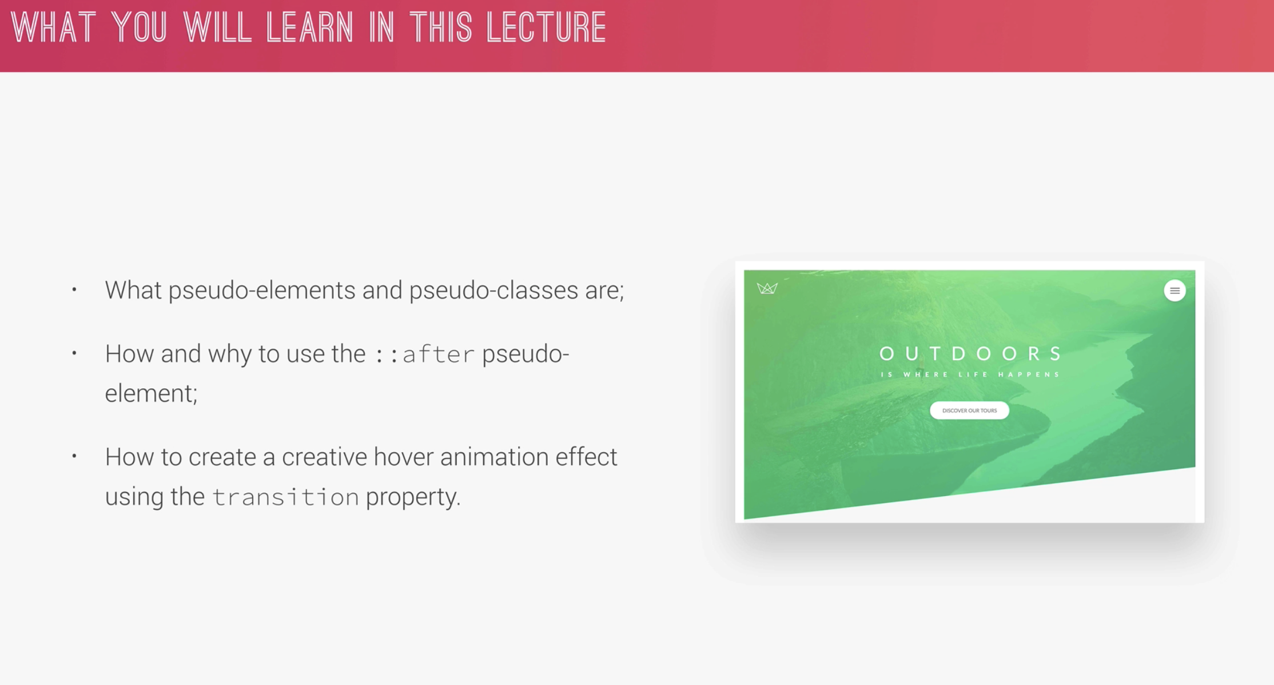

* .btn:link – is a special state sudo class of a selctor
* Padding: 15px 40px = 15px = top and bottom and 40px is left and right
* Display: inline-block – so not to display above of the sub1 element, to align properly
* Transform: transY(-3px) – is to look like It move up
* Box-shadow: 0 10px rgba (….) 0 = Y, 10px is how high it goes up then color of shadow with opacity
* Additional margin-bottom: 60px was added in heading-primary to move down the Read More button

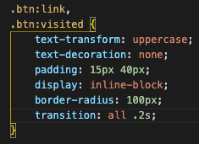 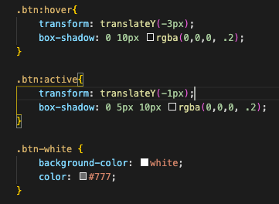

10. building animated button Part 2

* The use of ::after.
* Z-index: -1 is to put it behind
* Need to assign the button position as relative as ::after was set to absolute
* Transform: scale(2) is to make the element bigger
* Transition: all .4s: make the animation smoother and not look like just a snap
* Animation-fill-mode: backwards; makes the animation to act in reverse. Initially the button is visible then invisble then appear again. The backwards make it invisible the visible.

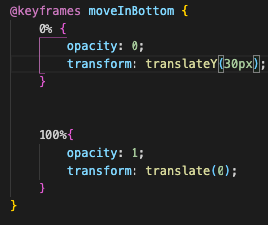 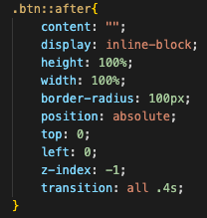 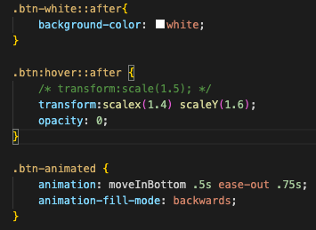

Section 3: How CSS Works: A look behind the scenes

11. Section Intro

12. The 3 pillars of writing good html and CSS

* 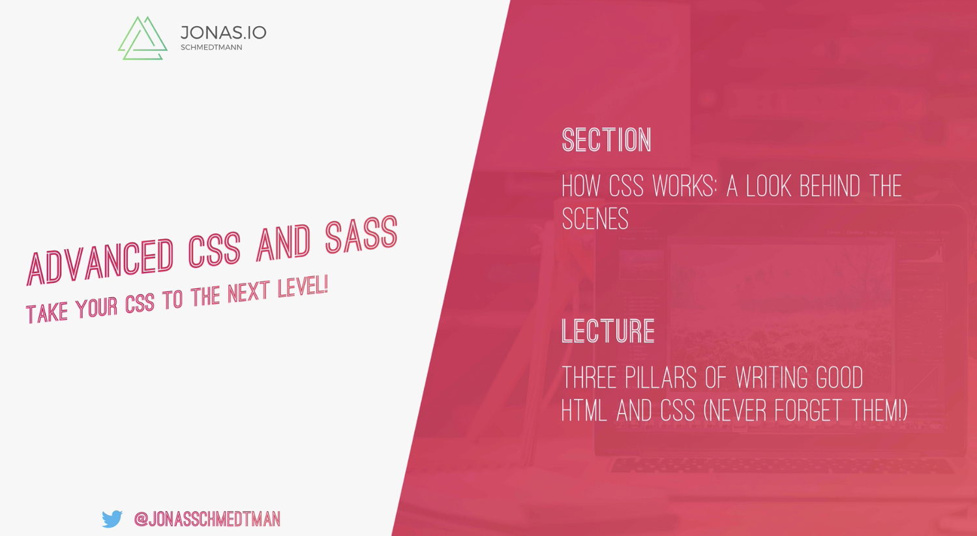
* 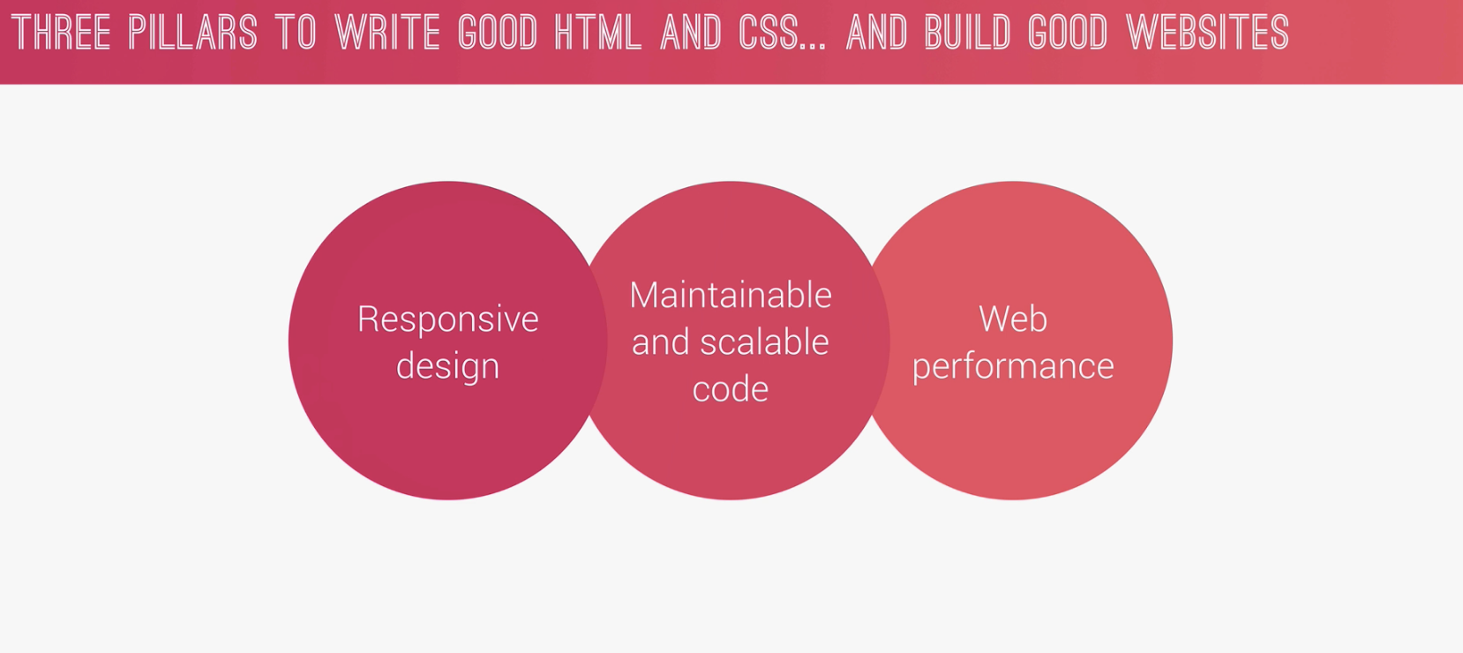
* 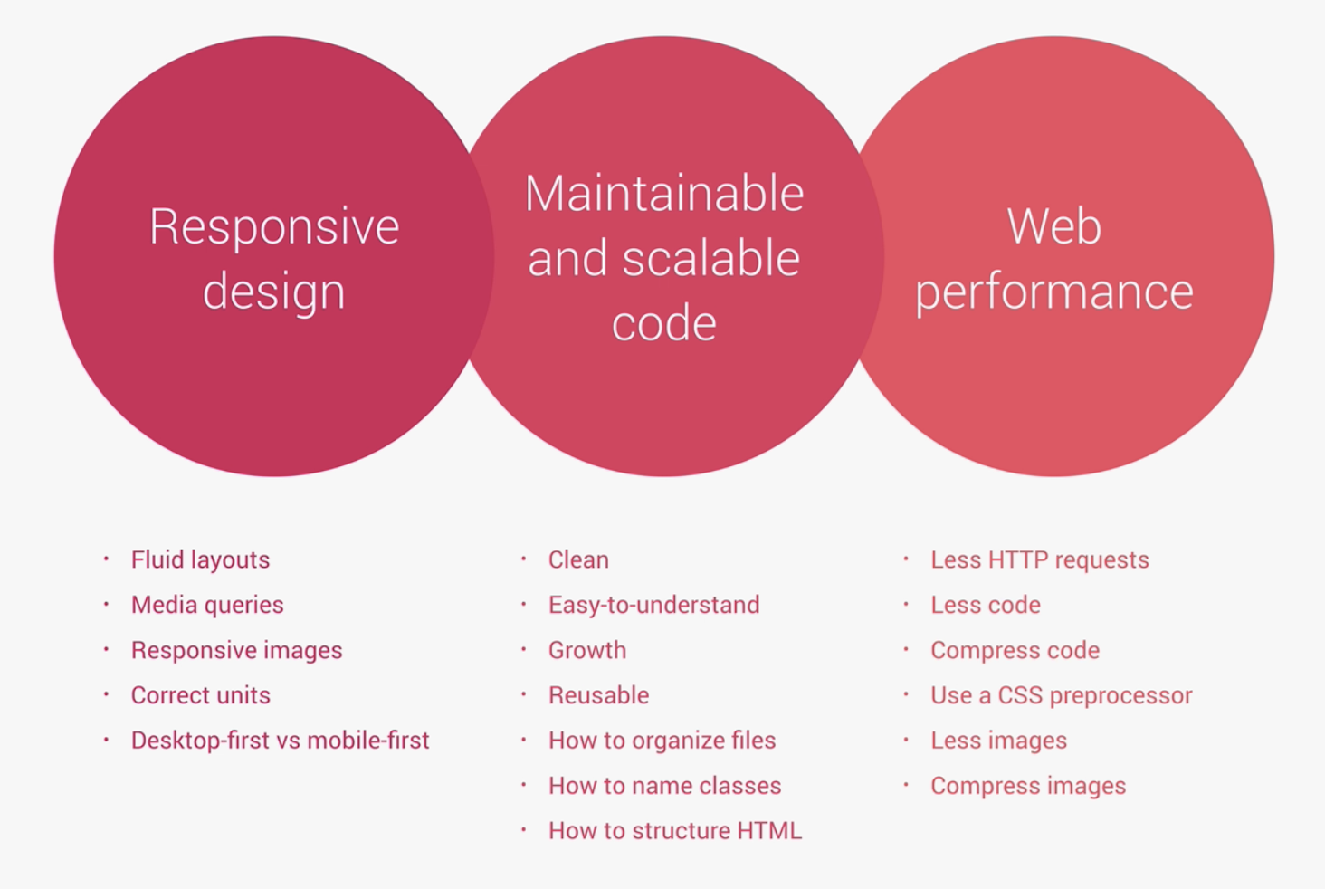

13. How CSS works behind the scene

* 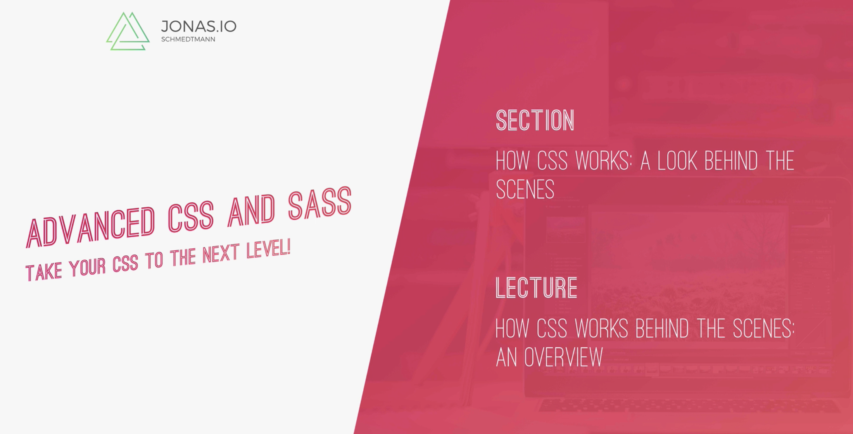

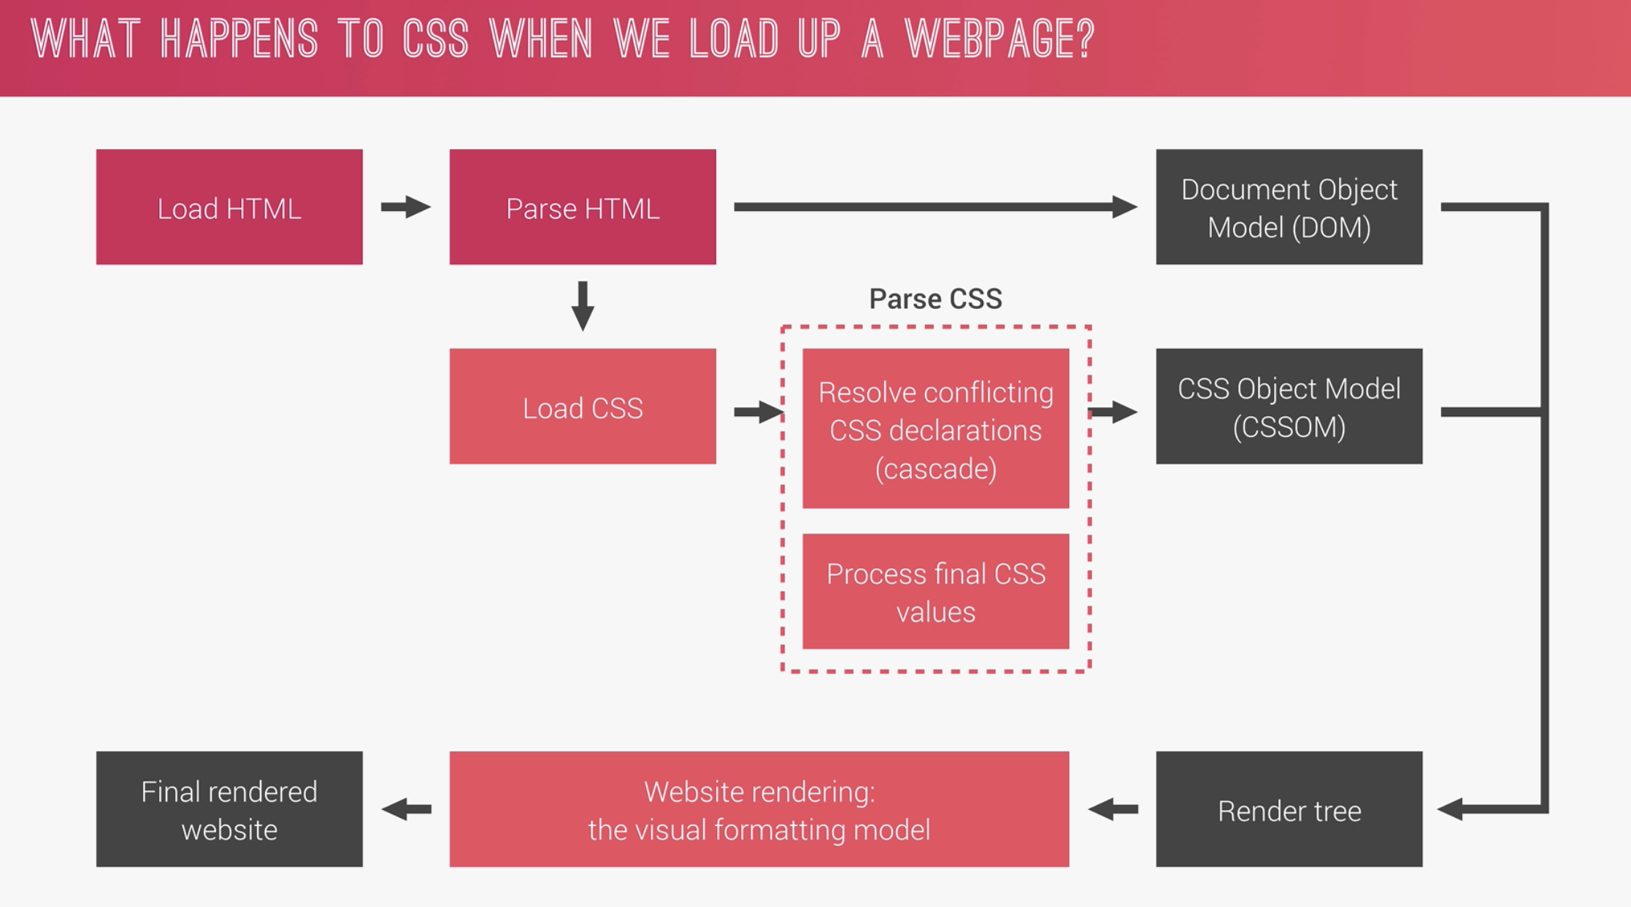

* 14. How CSS is parsed. Part 1 – the cascade and Specificity
* 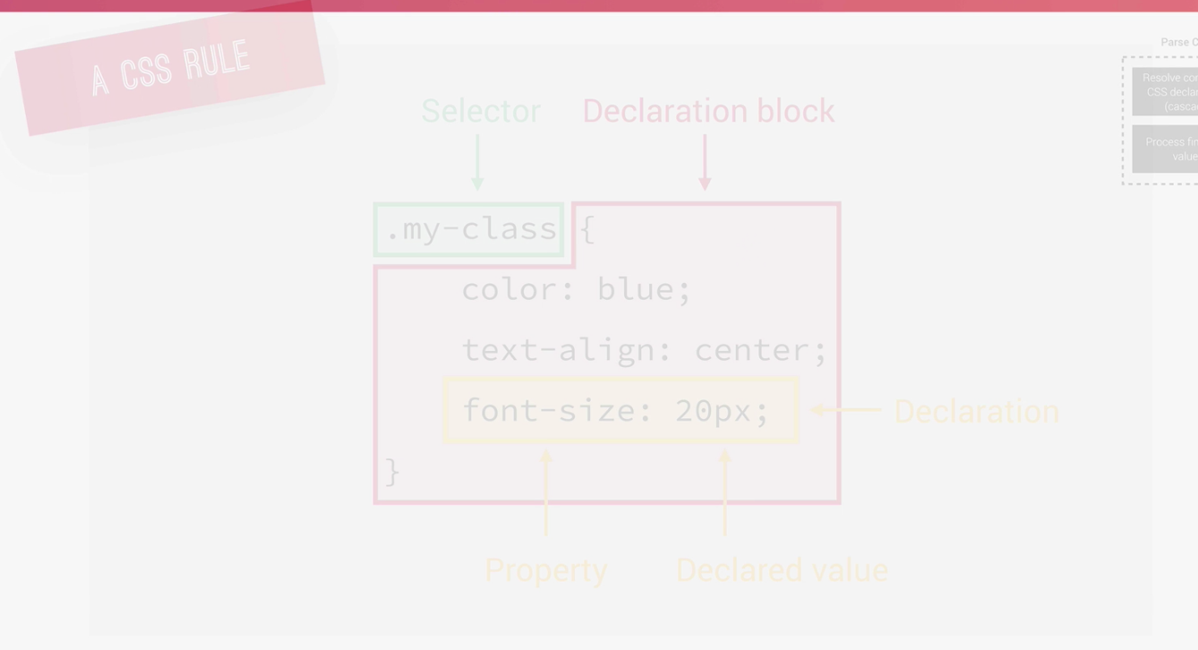
* 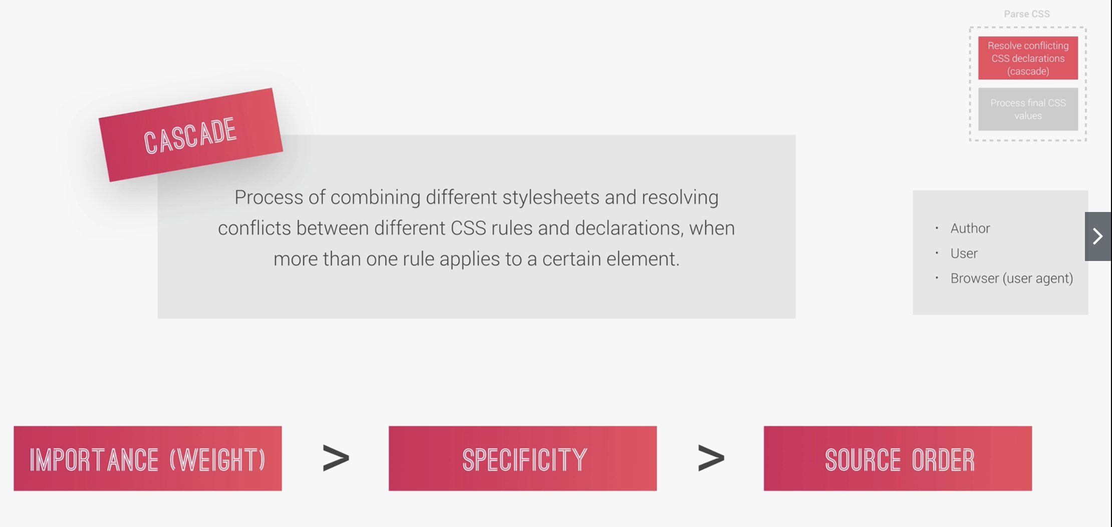
* 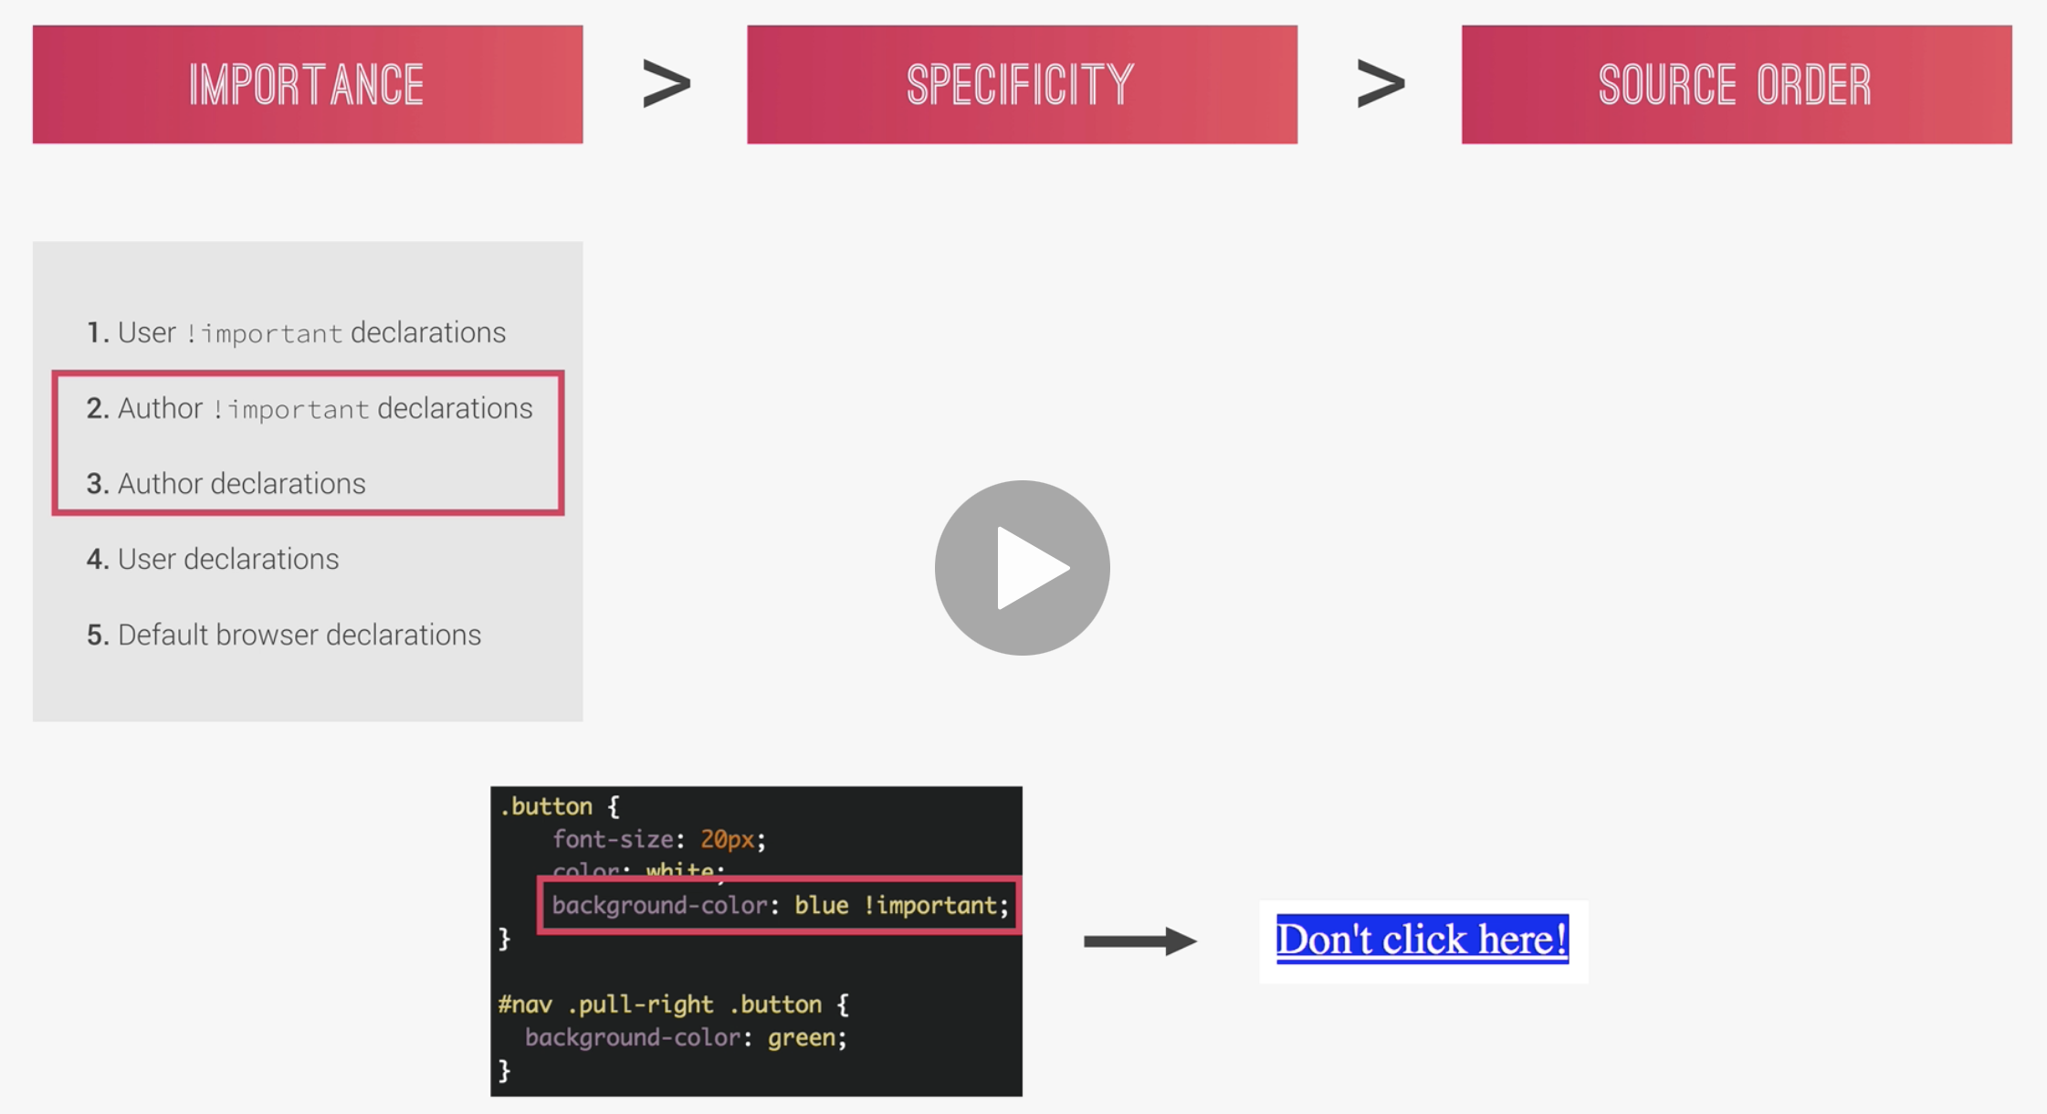
* 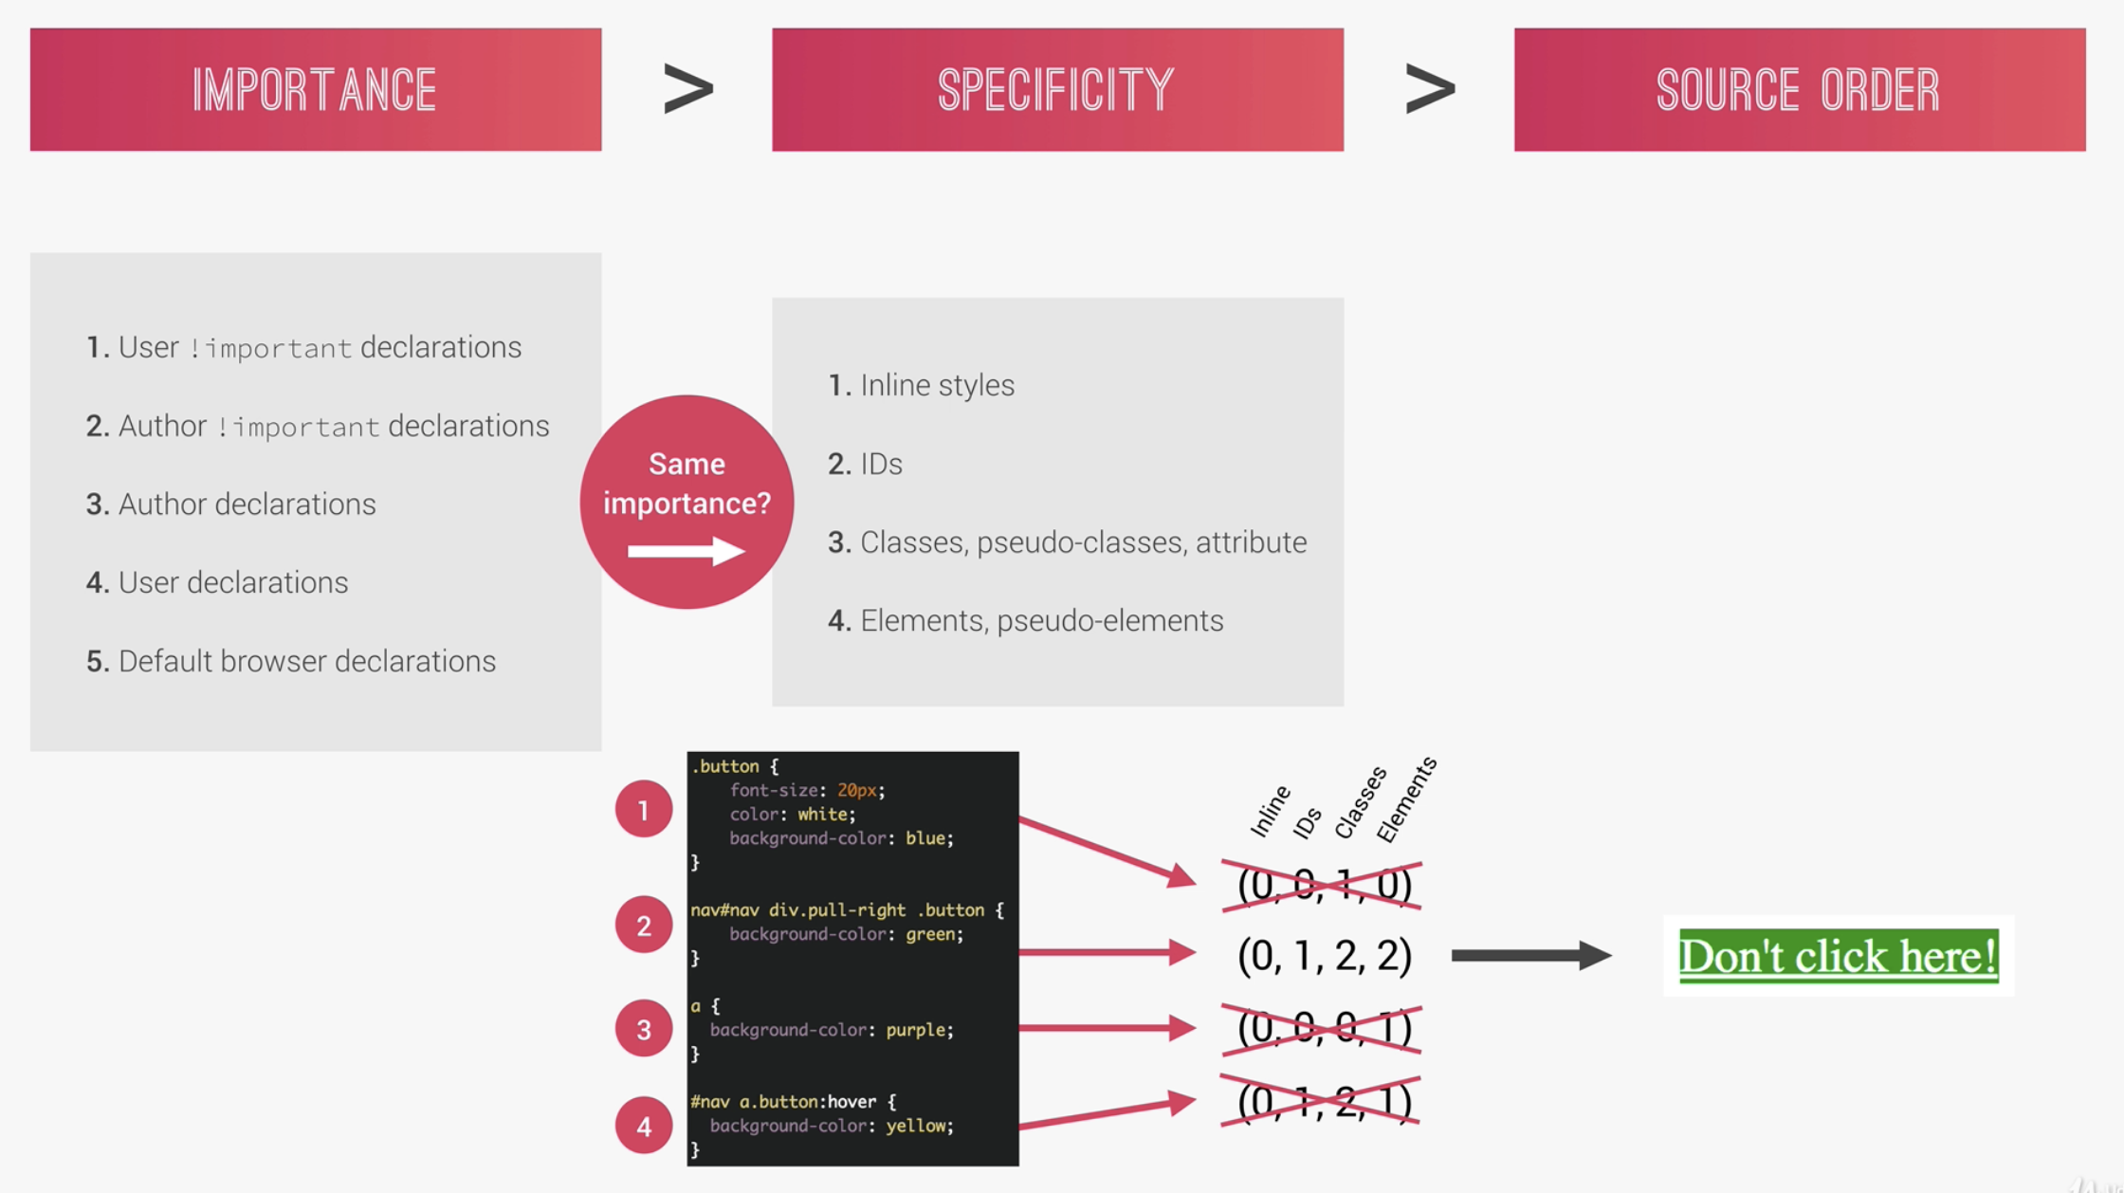
* 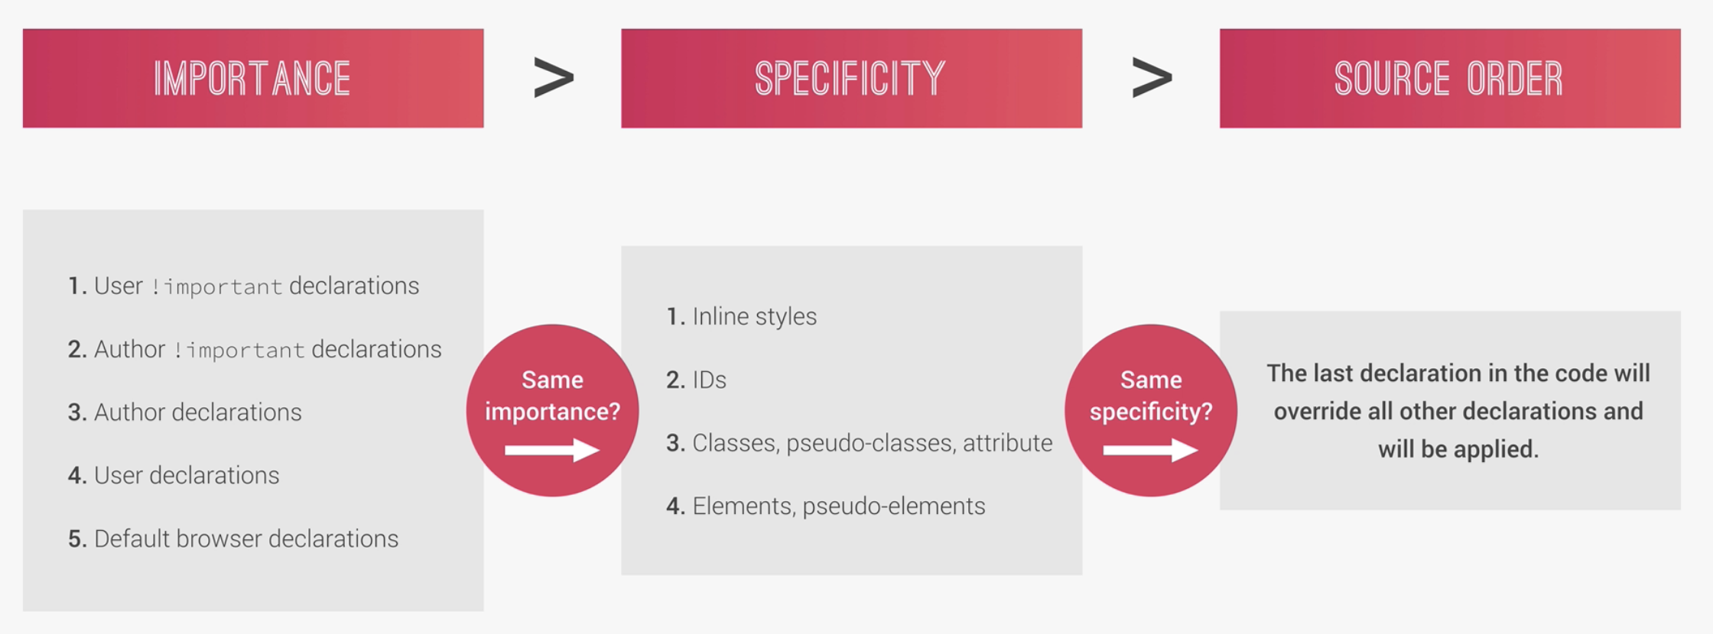
* 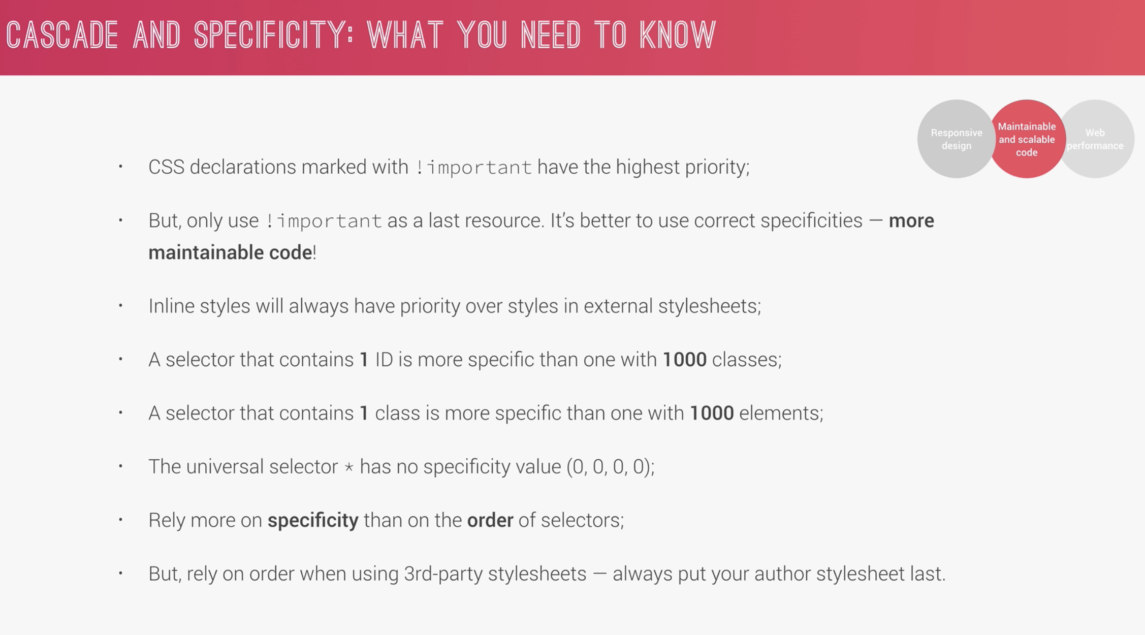

15. Specificity in Practice

* 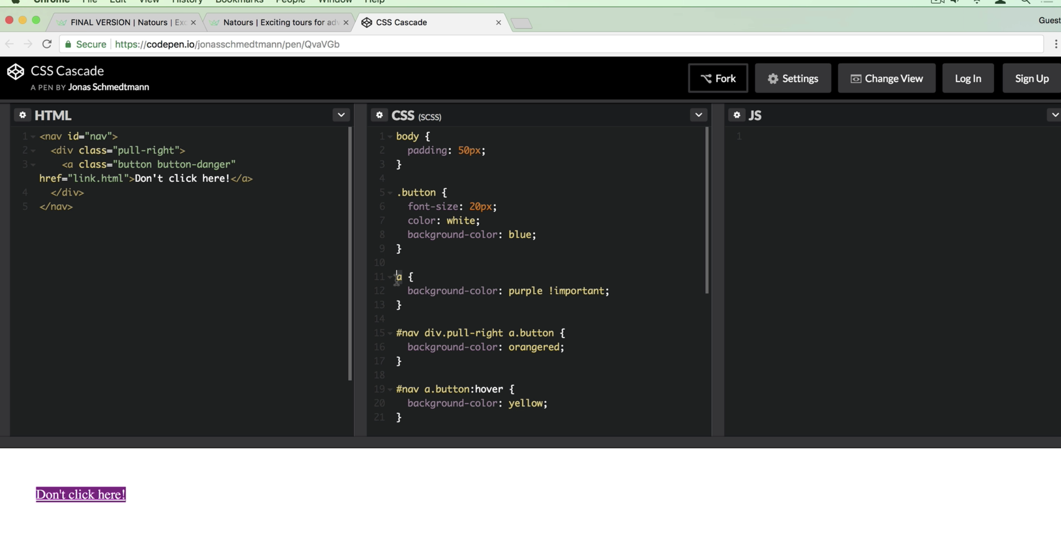
* The !important make it purple even though it has the lowest specificity
* The higher the score the higher the CSS be applied.

16. How CSS is parsed Part 2 – Value processing

* 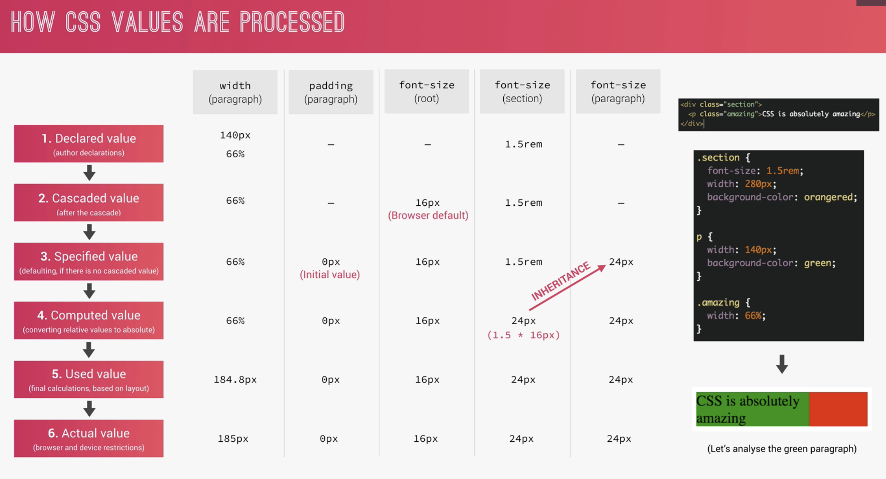
* Font (em) – reference is the parent
* Length (em) – reference is the current element
* REM (length and font) – reference is the root font size which in default is 16px
* VH and VW is 1% of viewport height and width. Browser automatically compute this.
* 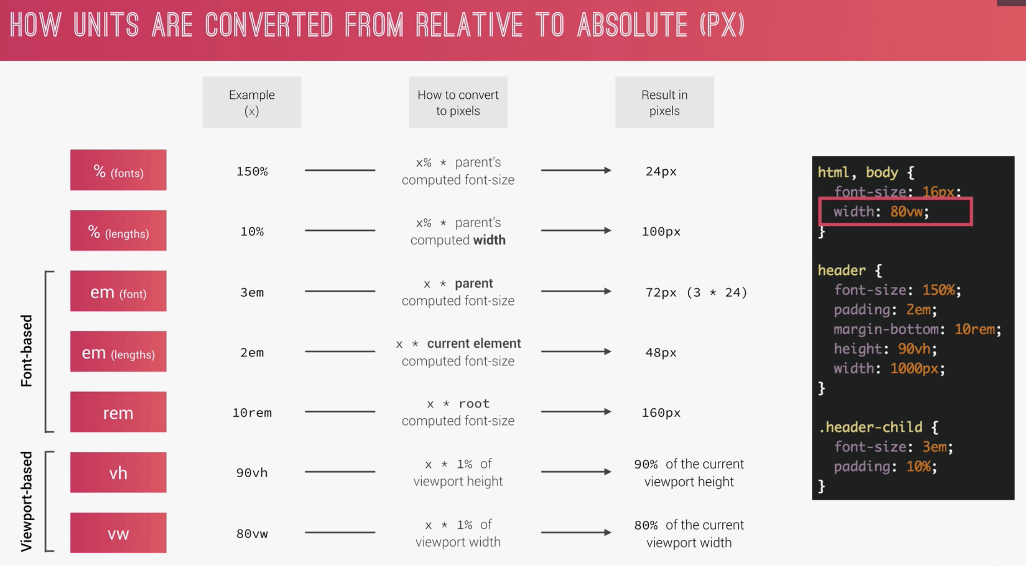
* 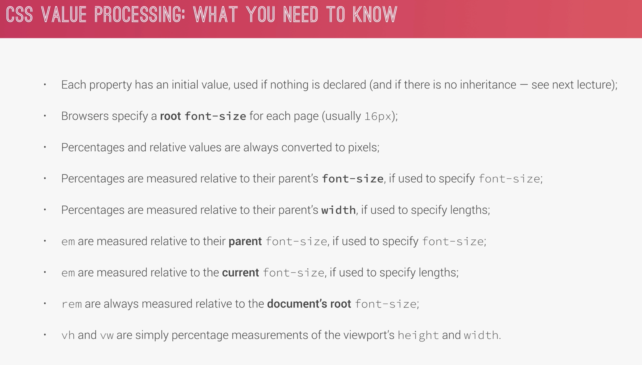

17. How CSS is parsed Part 3 – Inheritance

* Parent to children CSS property
* 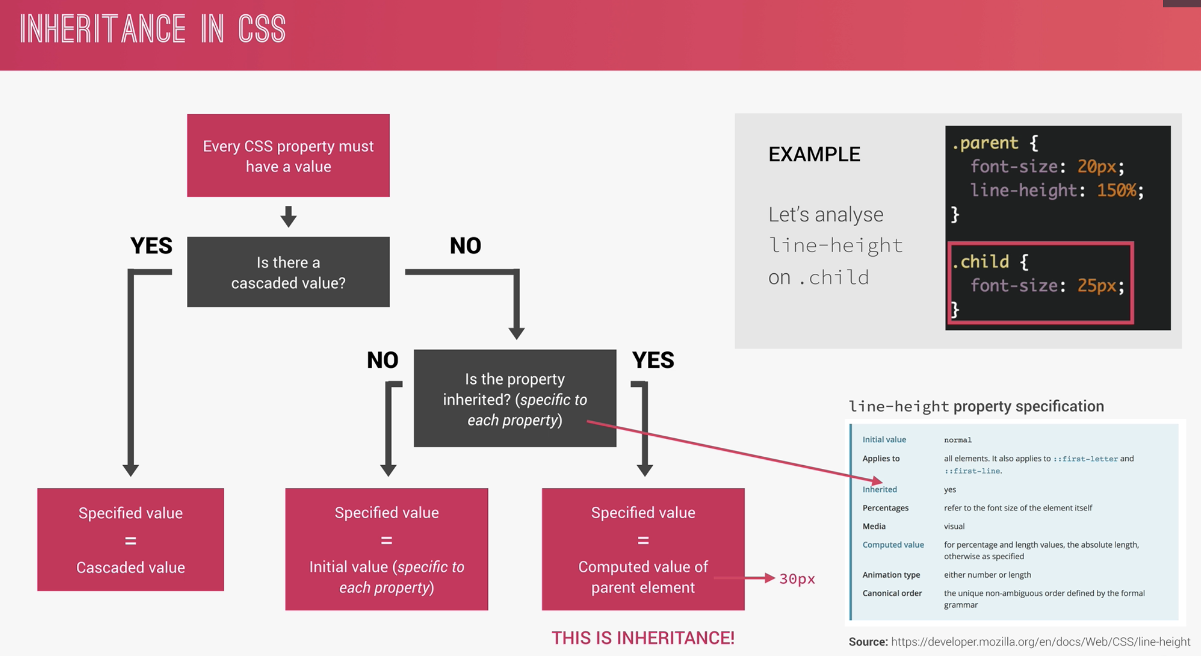
* 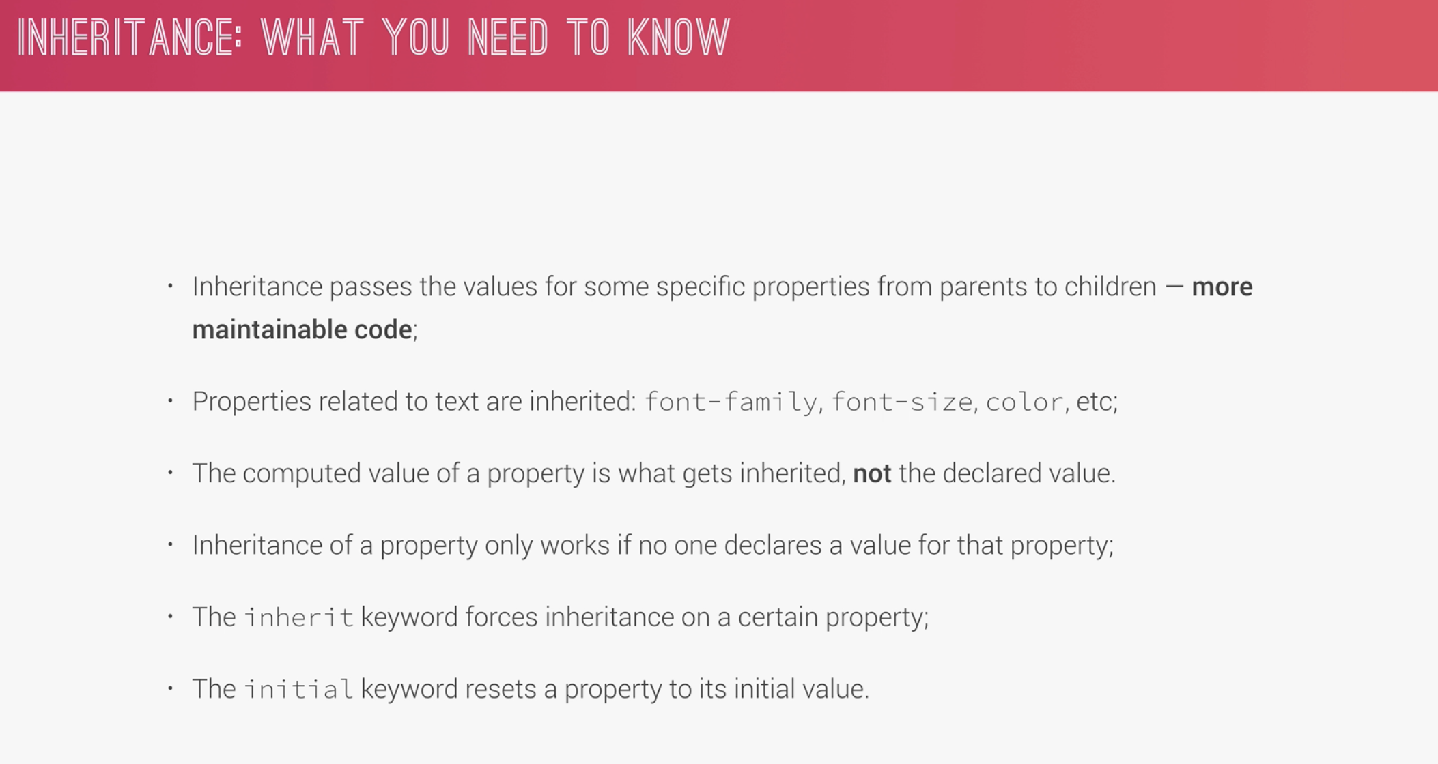

18. Converting px to REM

* 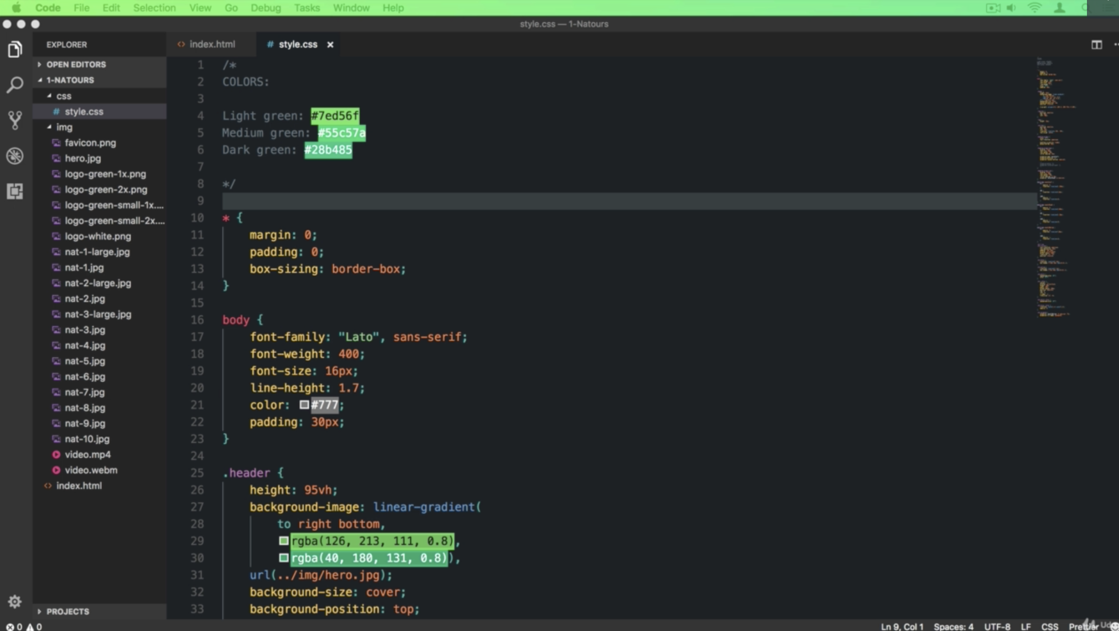 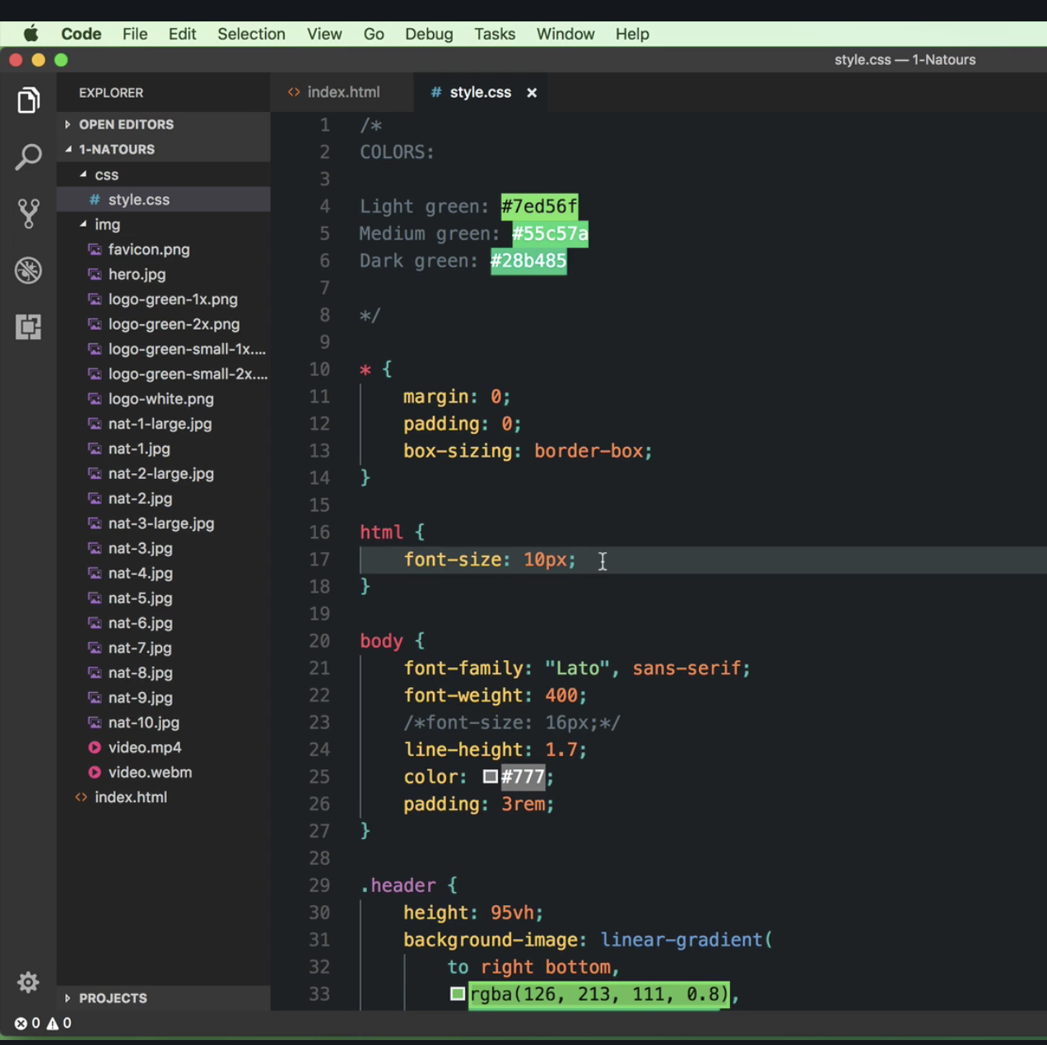
* It’s important to convert the font to rem so that the browser will automatically adjust it base on the screen size. This will make the page responsive. To make it better use 62.5% rather than 10px
* It’s a good practice to make the box-sizing set as inherit, use it as possible. Apply it also to all ::before and after pseudo elements
* 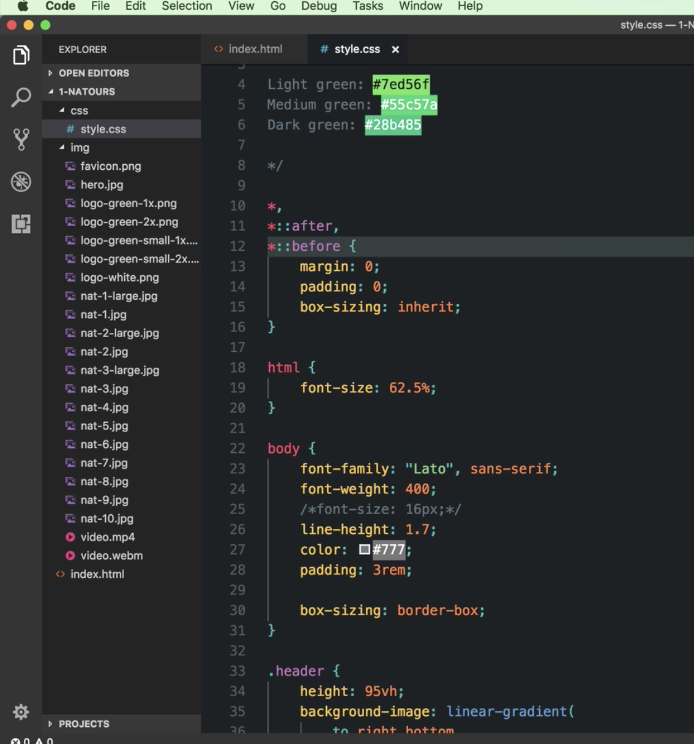

19. How CSS renders a website: the visual formatting model

* 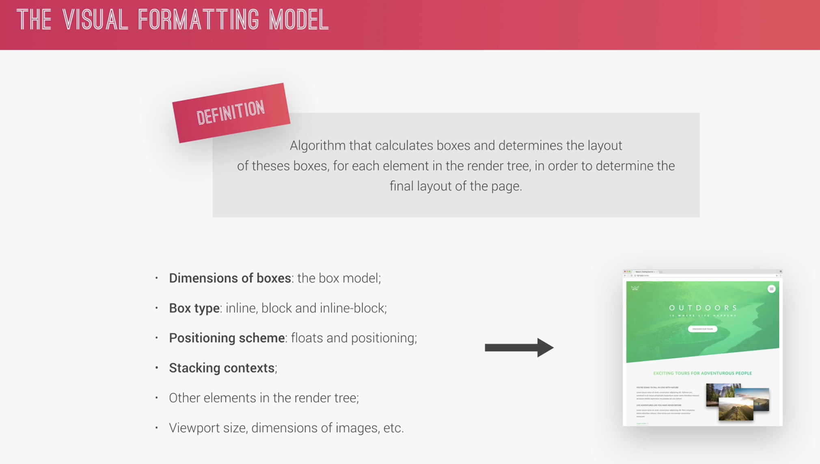
* 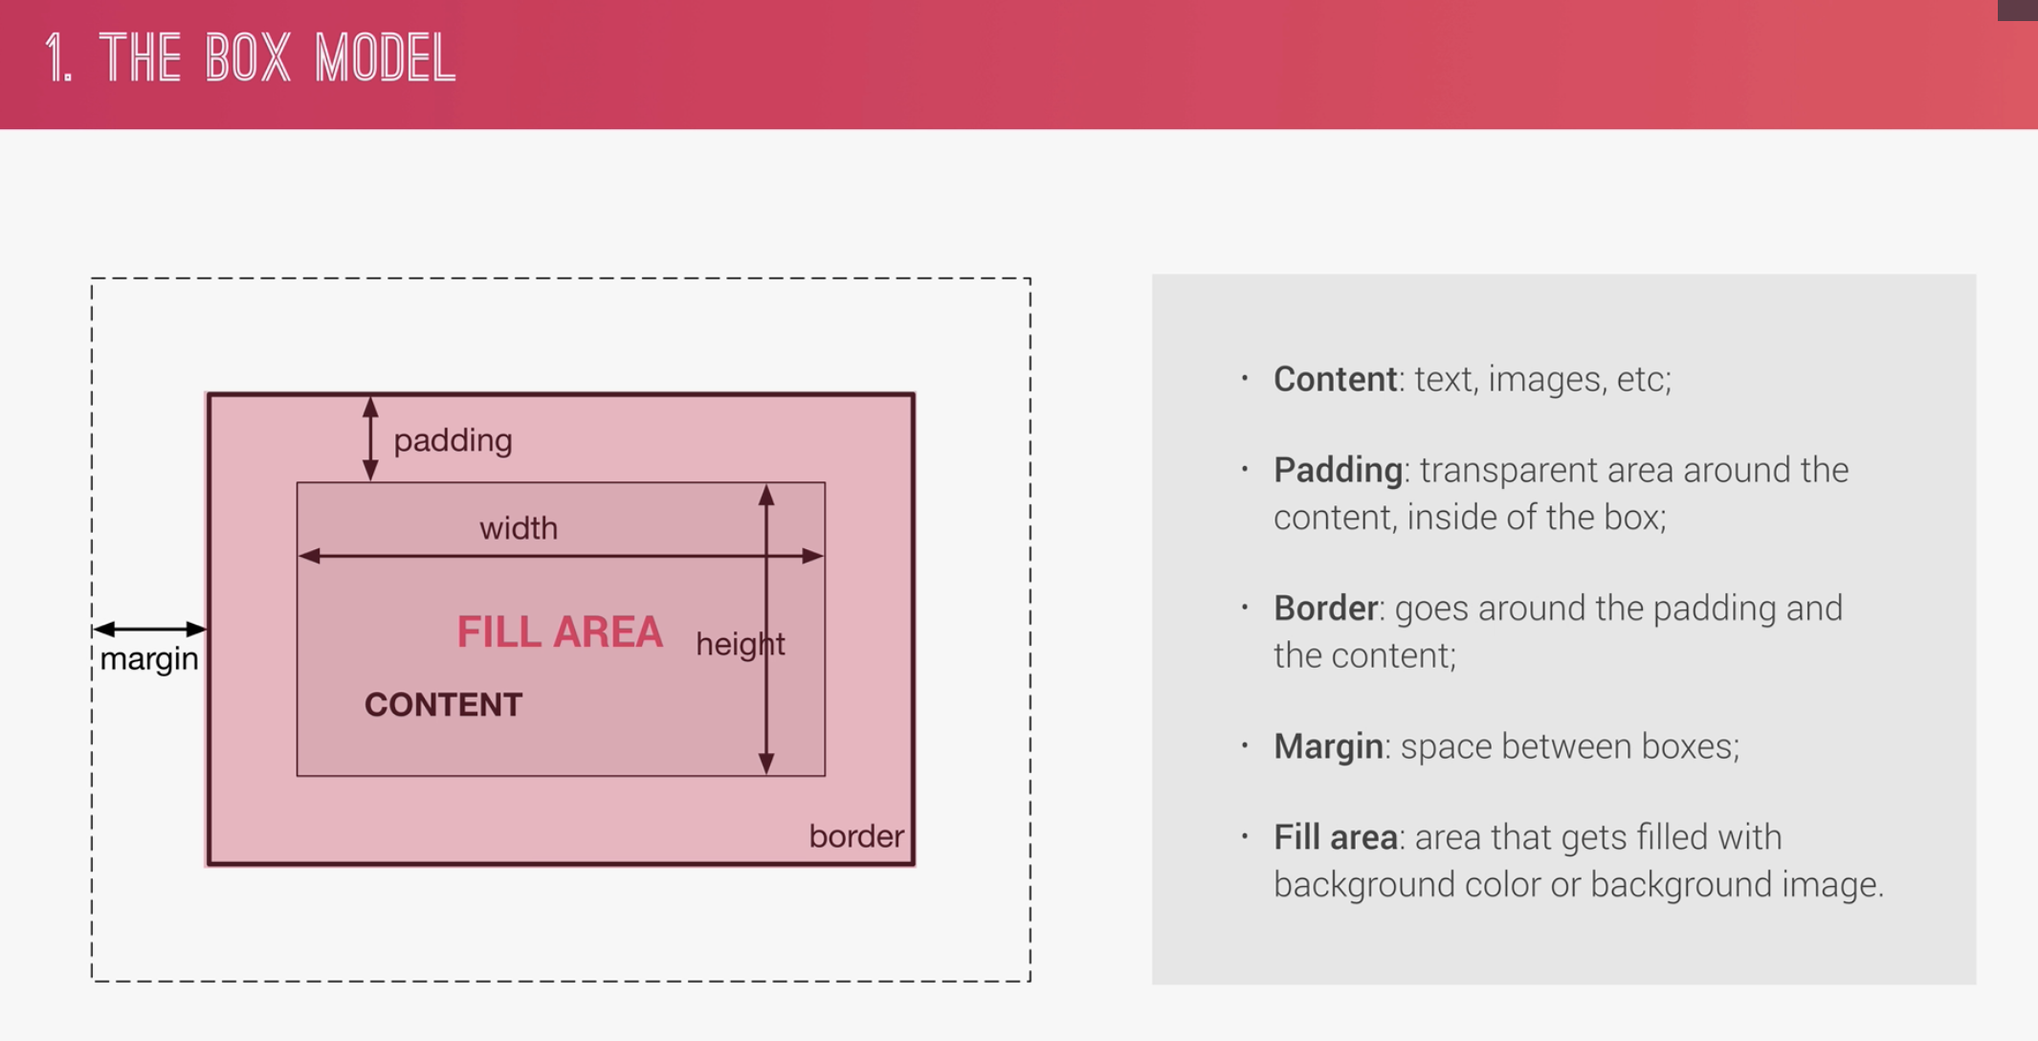
* 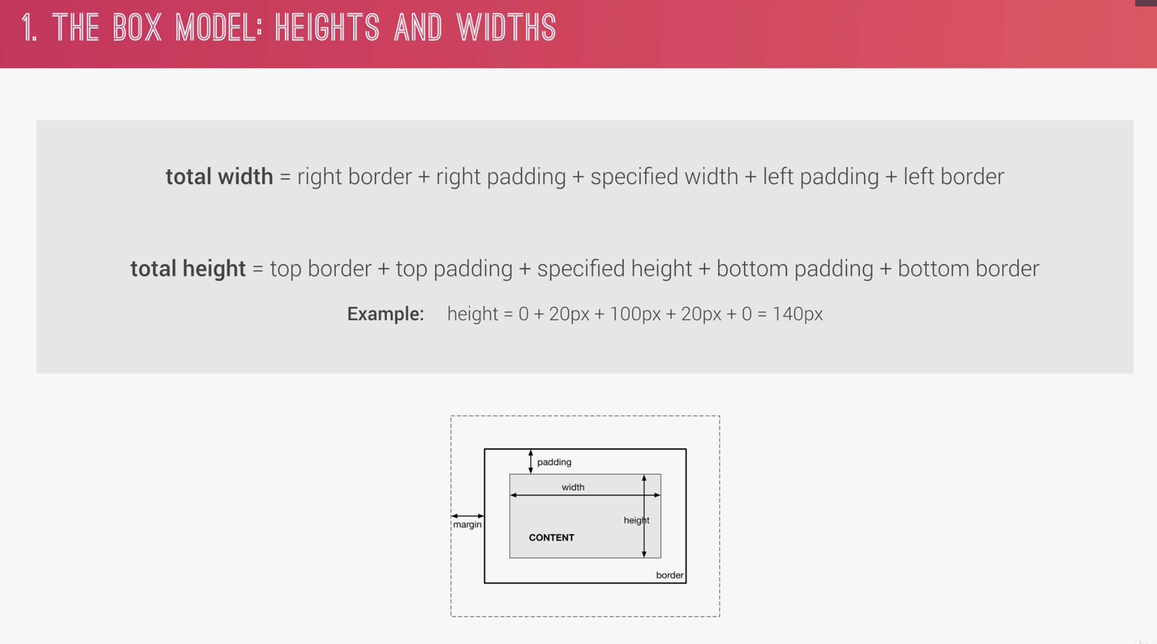
* 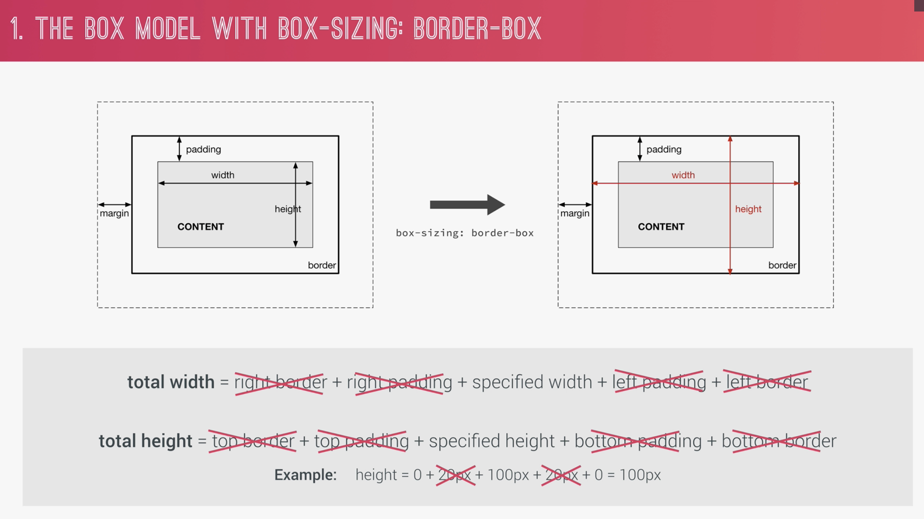
* Use of border-box
* 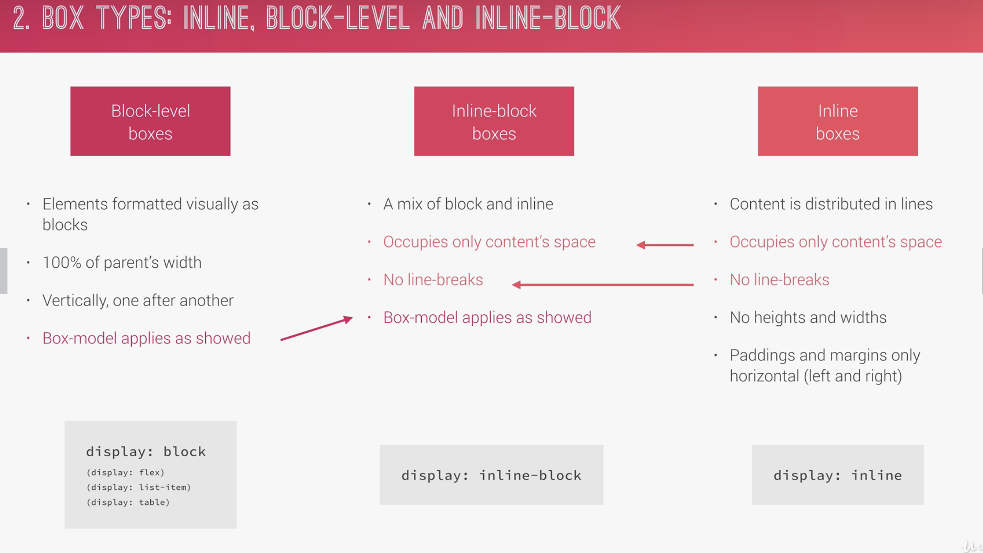
* 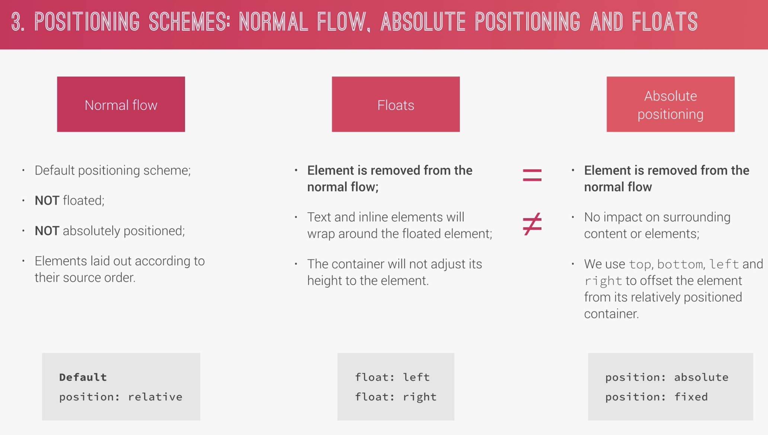
* 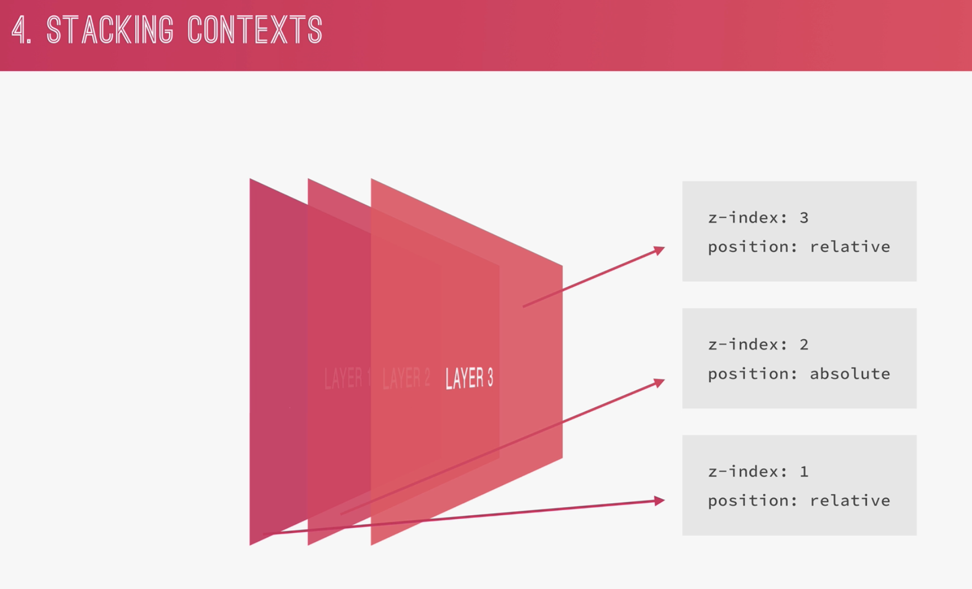

20. CSS Architecture, Components and BEM

* 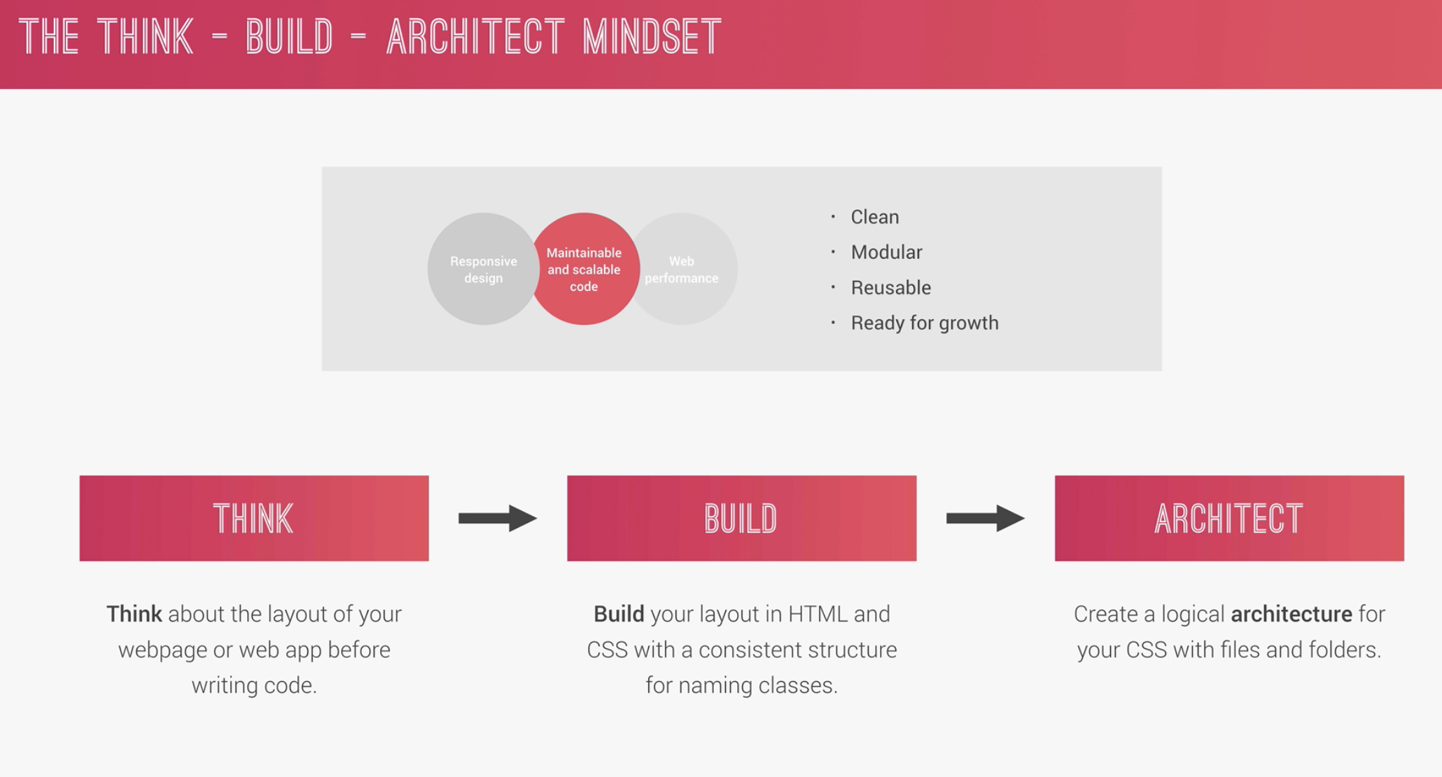
* 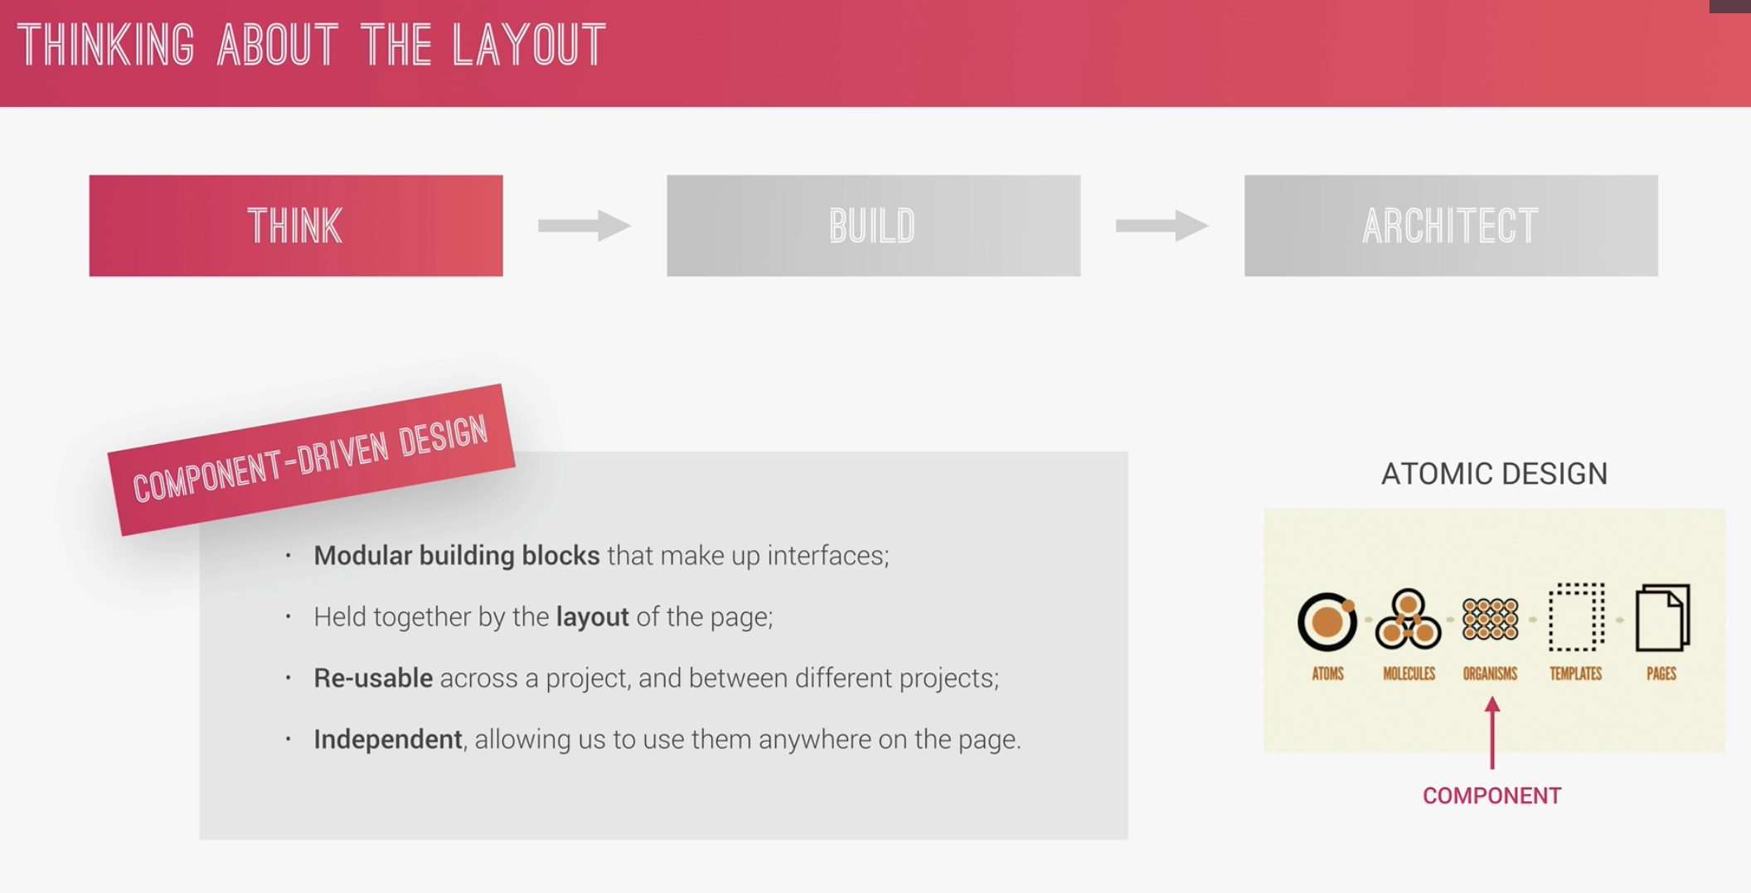
* Read the Markup
* 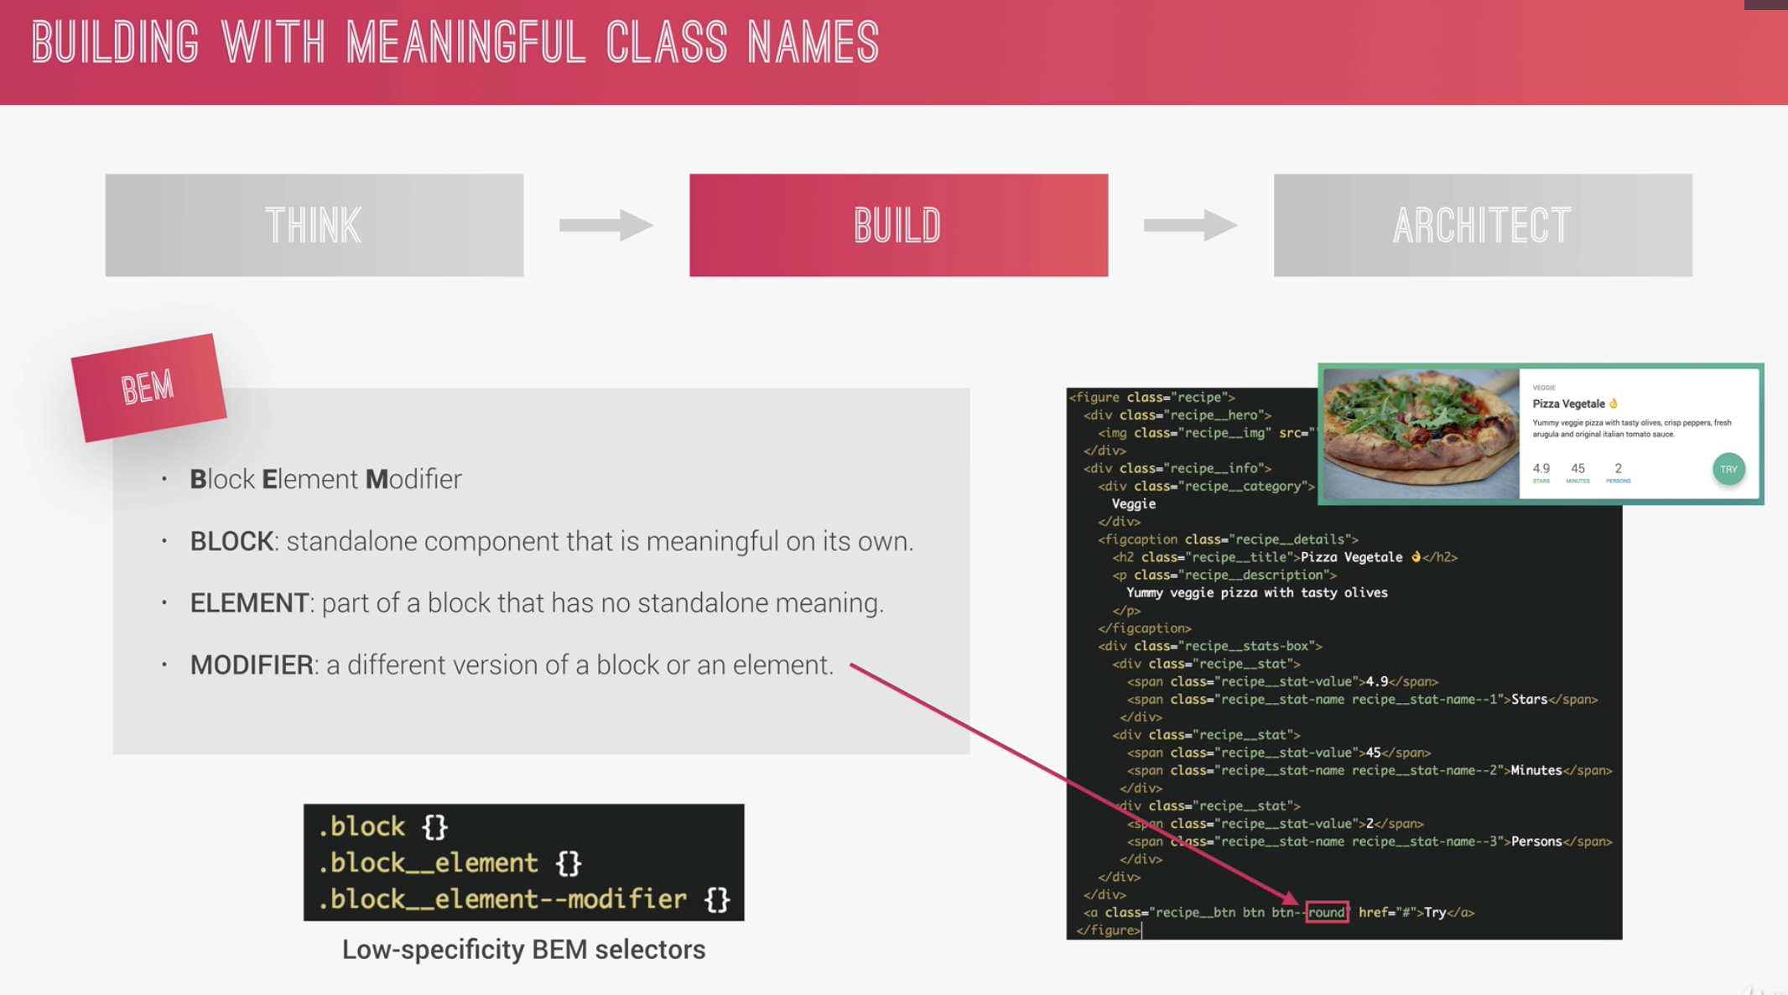
* 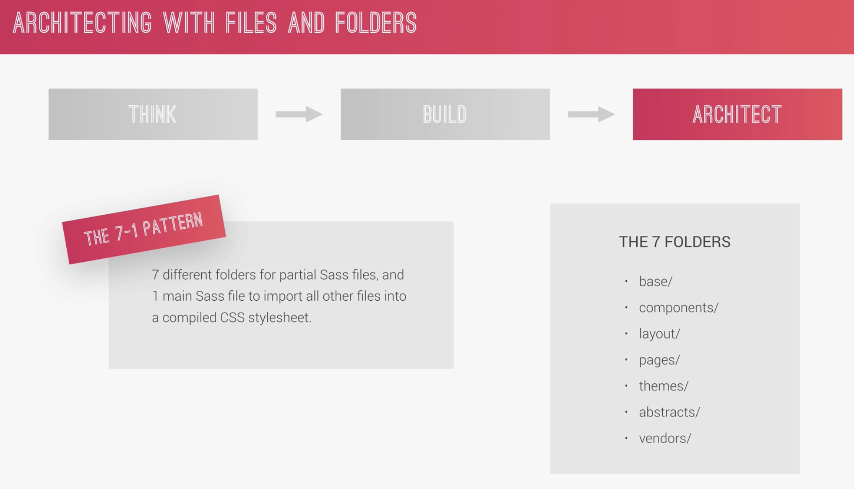

21. Implementing BEM in Natour Project

* Identify each block (header). Sample change logo-box to header__logo-box
* For the children of the heading-primary (stand-alone), heading-primary-main to heading-primary—main to indicate that main and sub are modifier
* no dash or underscore is a block; __ is an element; -- = modifier

22. Introduction to SASS and NPM

23. What is SASS

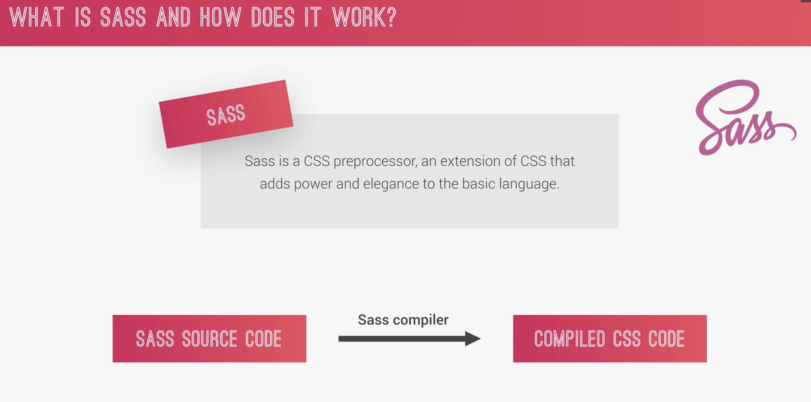

* 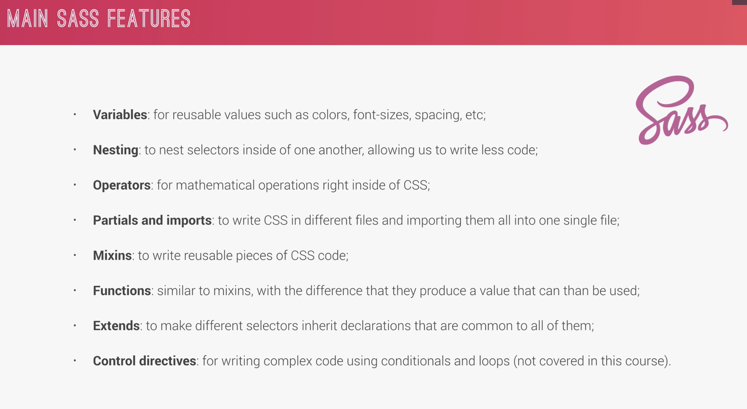
* 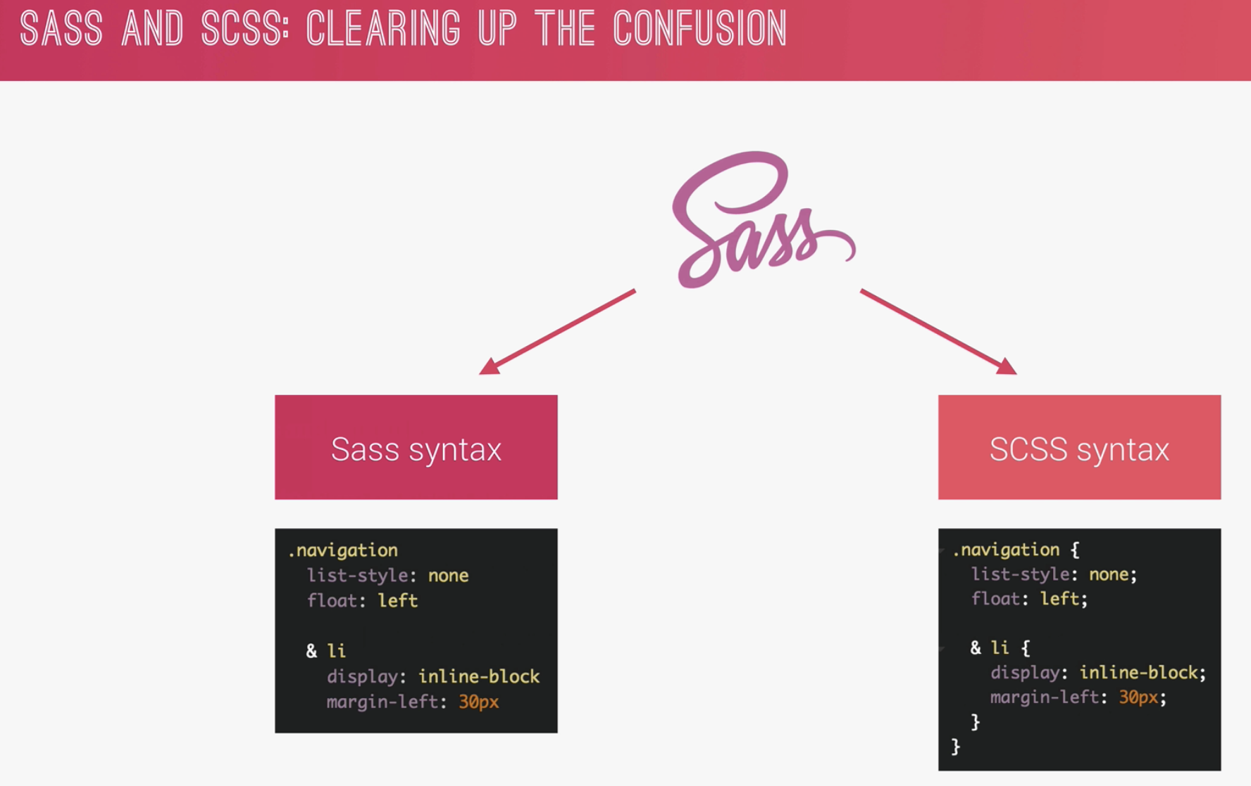

24. First step with SASS: variables and Nesting

* When we used the float (left and right) use also the clearfix class so as not to lost the styling of the elements.
* 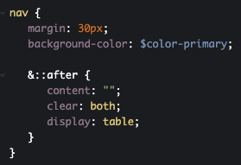 === & is the .clearfix
* Darken and lighten is another feature of SASS for colors as below
* 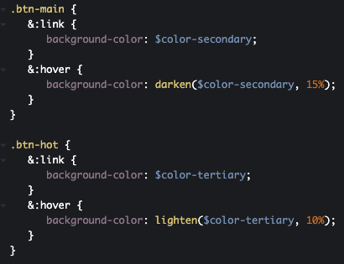
* <https://codepen.io/shernof/pen/NWqOeqP?editors=1100>

25. First step with SASS: Mixins, Extends and Functions

* Mixin is a re-usable piece of code
* 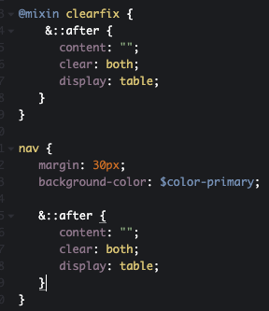 == implementation of mixin 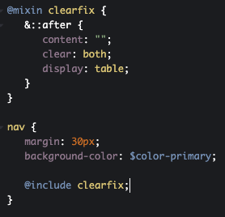
* We can pass an argument to mixin
* 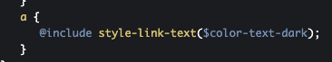
* 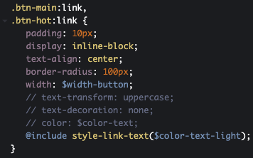 the parameter (color-text-light/dark) is now pass to the mixin as below
* 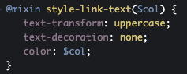
* Mixin can be use pass with or without argument
* Darken() and lighten() are featured functions in SCSS
* Function
* 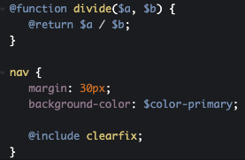 === 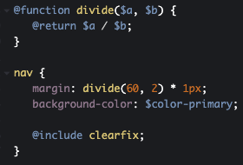
* Extends
* 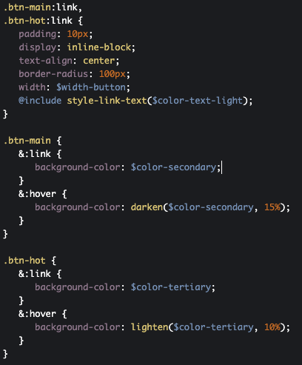 === 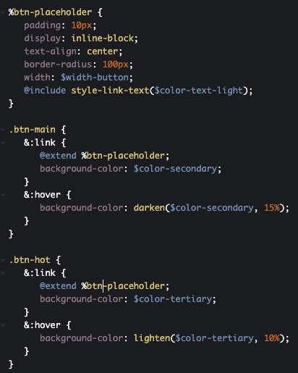

26. A brief intro to command line

* Ls = to see the content of the folder in windows = dir
* Cd desktop is change directory to desktop
* Cd.. move up one folder
* Clear
* Mkdir =make directory
* Cd /volumes = to see the available drives
* Cp = copy; cp index.js .. = this will copy index.js to the folder up one
* Mv = move; mv index.js ..
* Cd web\ dev = go to the directory with space in name
* Rm = remove; del in windows
* Rm -r = to remove folder
* Open hero.jpg; open file

27. NPM Packages: Let’s install SASS locally

* 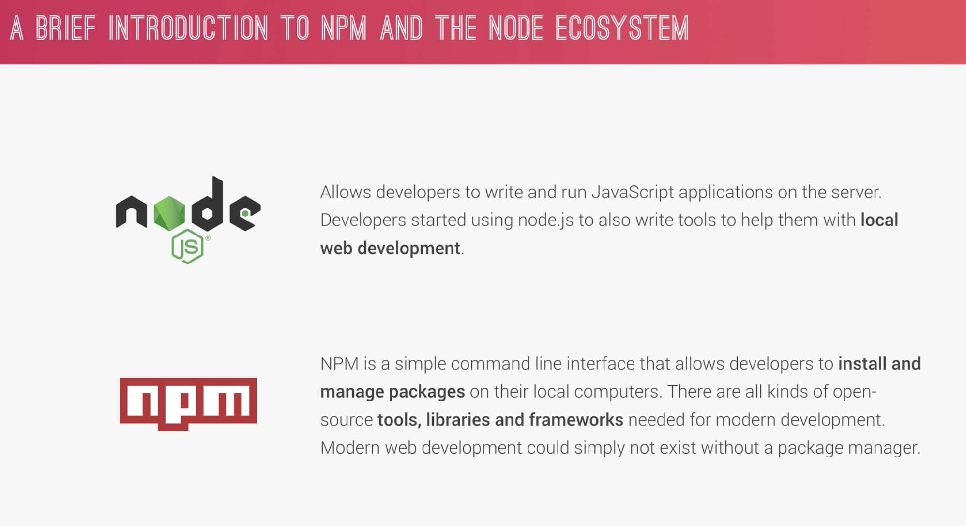
* Install node.js from website
* Node -v = test if node is installed
* Create a package.json; npm init
* Install sass compiler = npm install node-sass –save-dev
* Npm install jquery –save
* Npm install – it will re-install the nm base from json file.
* Npm uninstall jquery –save

28. NPM scripts: Let’s write and compile SASS locally

* Mkdir sass
* Touch main.scss inside the sass folder
* Create the sass script
* 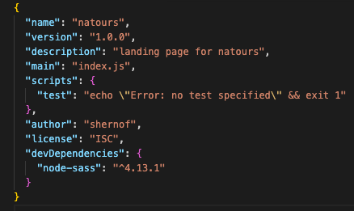 === 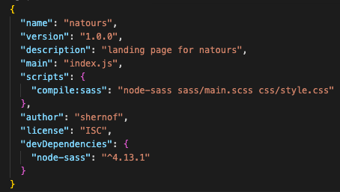
* Node-sass = name of package
* Input
* Ouput file – compiled css
* In terminal = npm run compile:sass
* -w in packagejson means watch

29. The easiest way of reloading page automatically on file change

* Npm install live-server -g

Section 5: Natours Project – Using Advanced CSS and Sass (Part 2)

30. Section Intro

31. Converting CSS to SASS variables and nesting

* See main.scss vs main orig.scss

32. Implement 7-1 CSS Architecture with SASS

* 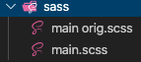 == 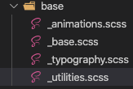
* Basically the main.css becomes an import page as most of the css codes were placed in their respective folders and files (in the left side)
* 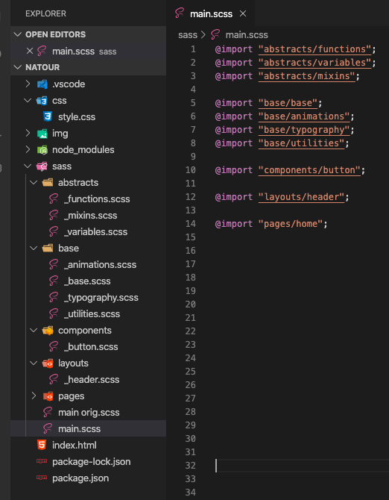

33. Review: Basic principles of responsive designs and lay out types

* 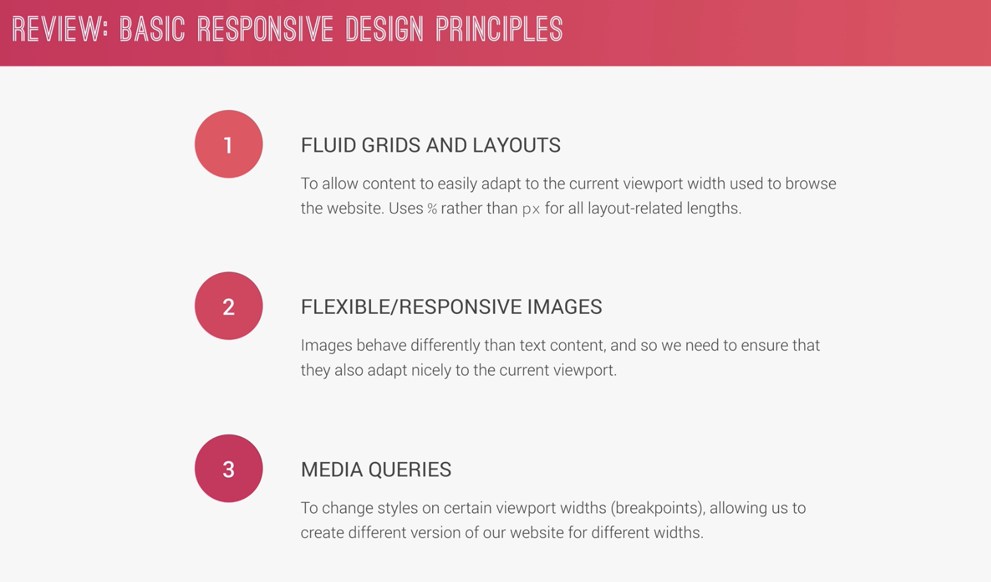
* 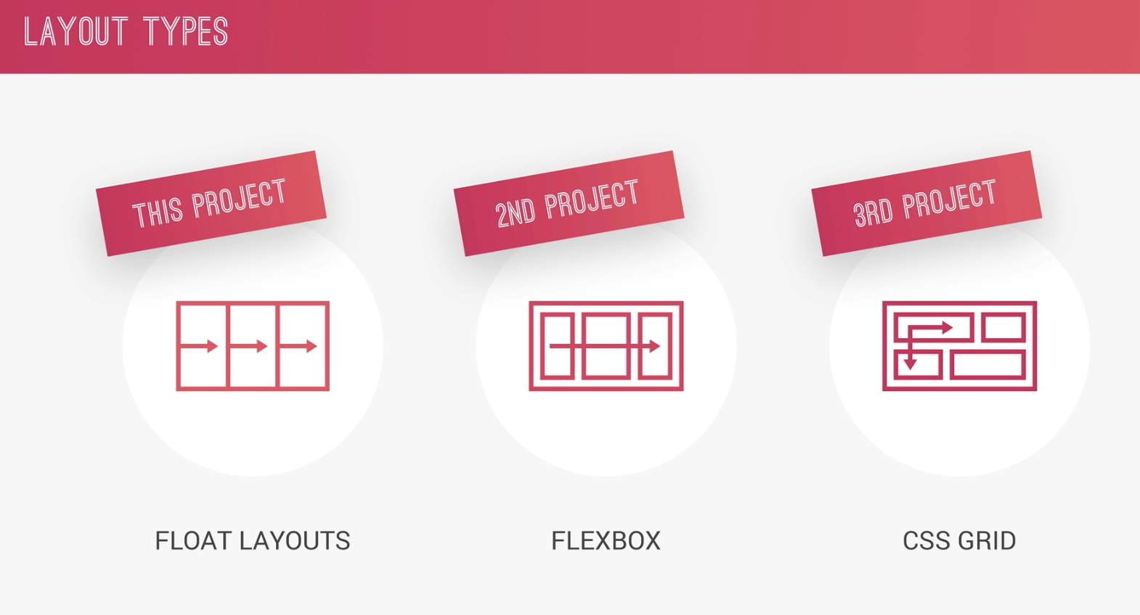

34. Building custom grid with floats

* 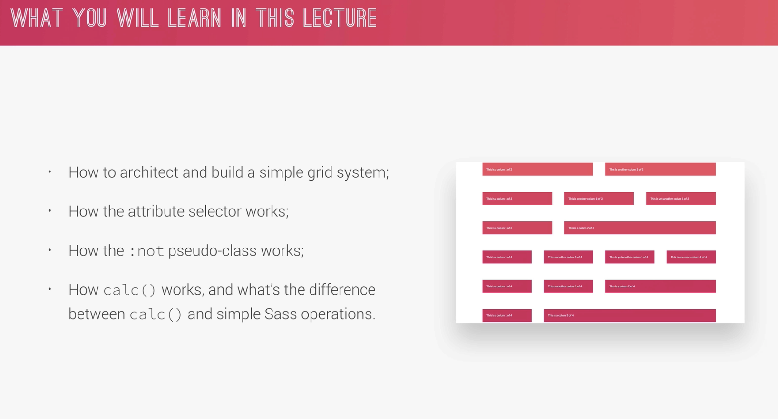
* 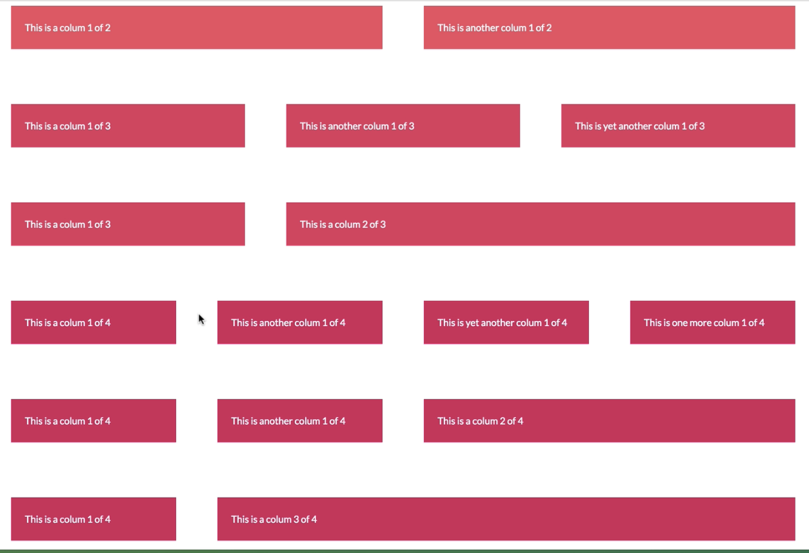
* Use of calc()
* Class^=”col-“; it will select all elements that starts with col-
* Class*=”col-“; it will select all elements that contains with col-
* Class^=”col-“; it will select all elements that ends with col-

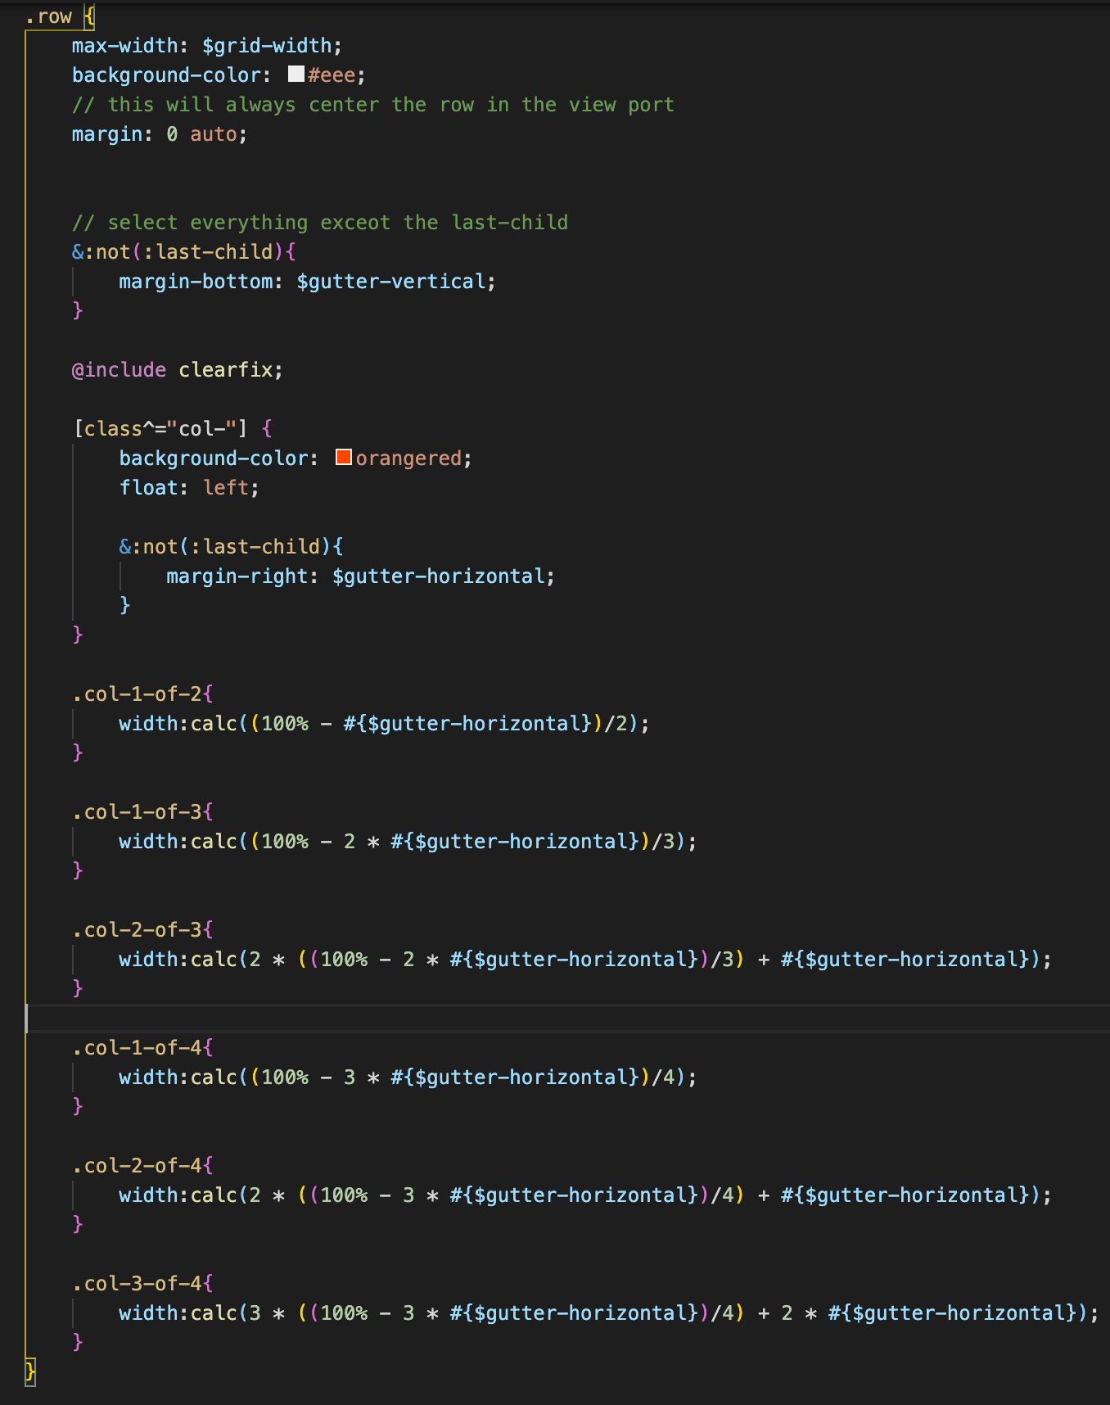

35. Building the About Section part 1

* 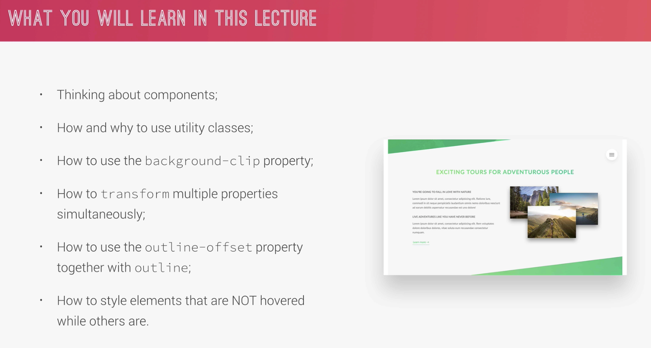
* 
* Use of:
* display: inline-block
* -webkit
* Transform: skew;
* U-center-text – this class means utility and the class name can be reuse anywhere we want to center the element
* U-margin-bottom-8 is also another utility to set the bottom margin to 8rem

36. Building the Sbout Section Part 2

* Continue styling the left side of the row
* Continue the use of transition and transform for the bottom
* Assigning variable like the $default-font-size = 1.6rem

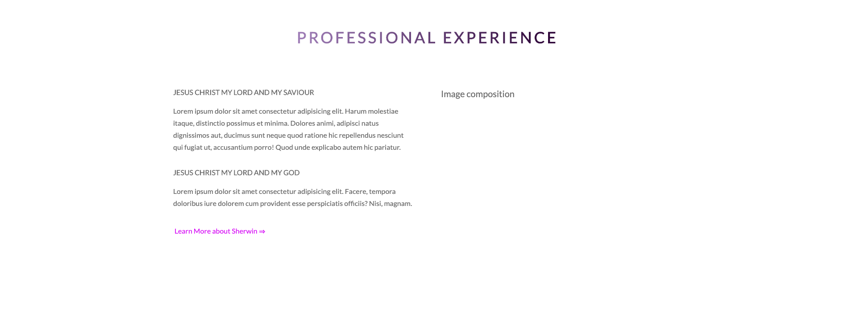.

37. Building the Sbout Section Part 3

* Use of the 2nd column of the row
* This will setup the images. It will make the image grow and in front while thriginal image in front will be at the back.
* Will learn more of the implementation of BEM for this image components
* Position:absolute; will define it’s position on top of each other. .composition will b the position.relativ
* Learned how to position in overlapping manner
* To make the image appear over another imager is to use the z-index. At hover should be greater than default.
* Use of the outline to have a lie when hovered



38. Building the Feature Section

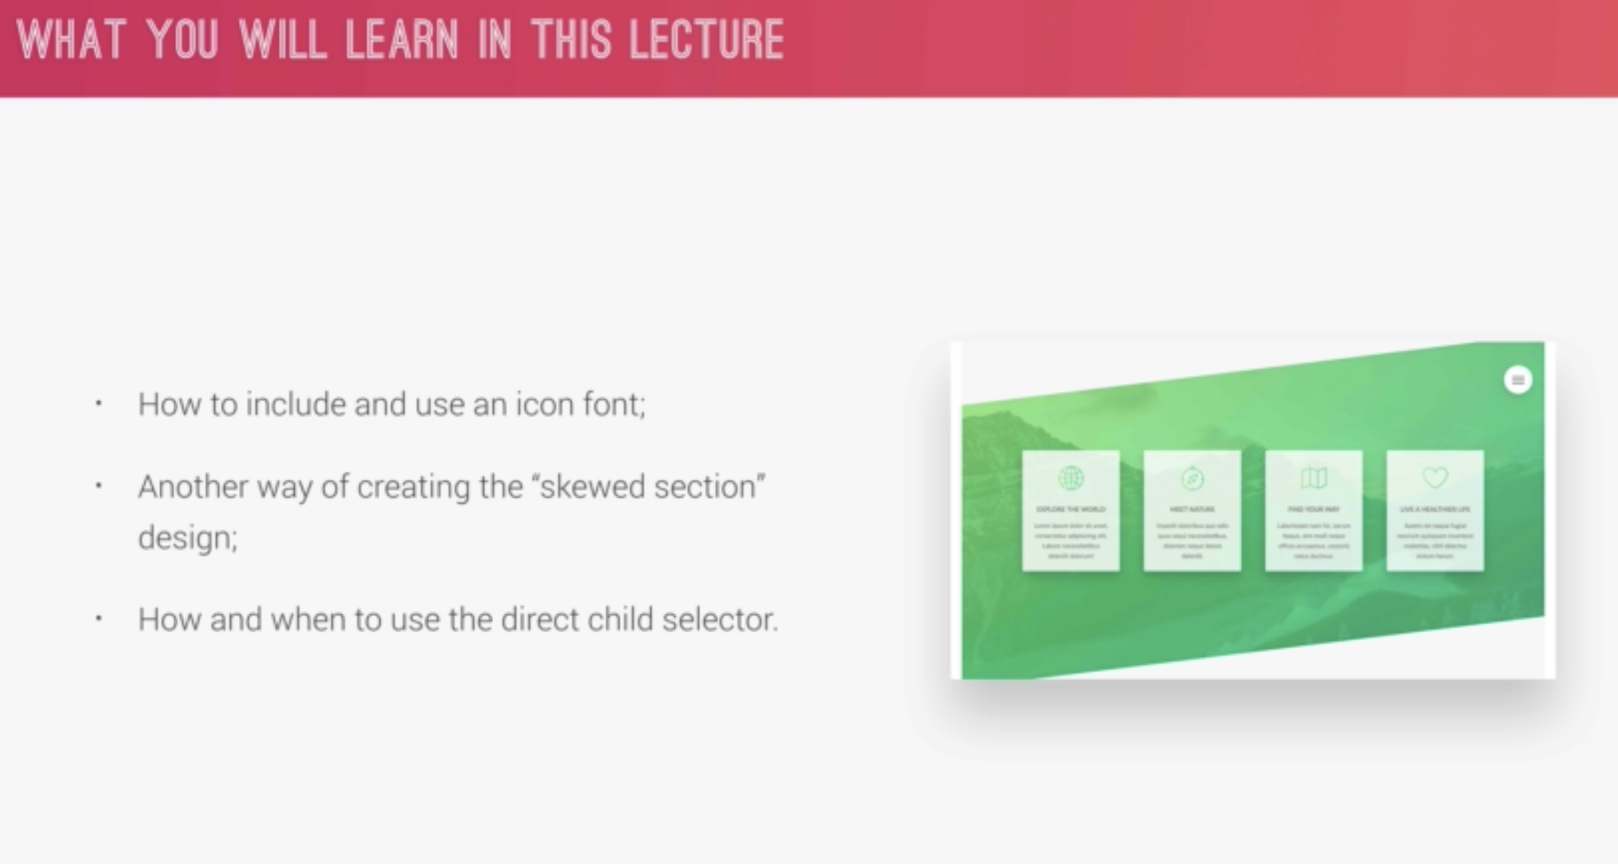

* Use of linea.io, add it as a stylesheet in the html to use the icons
* Reused the background properties in the header and applied in this section
* Reuse the utility u-margin-bottom-small
* Use of transform: skewY(-7deg to skew the background image
* & > * {}) is for direct child

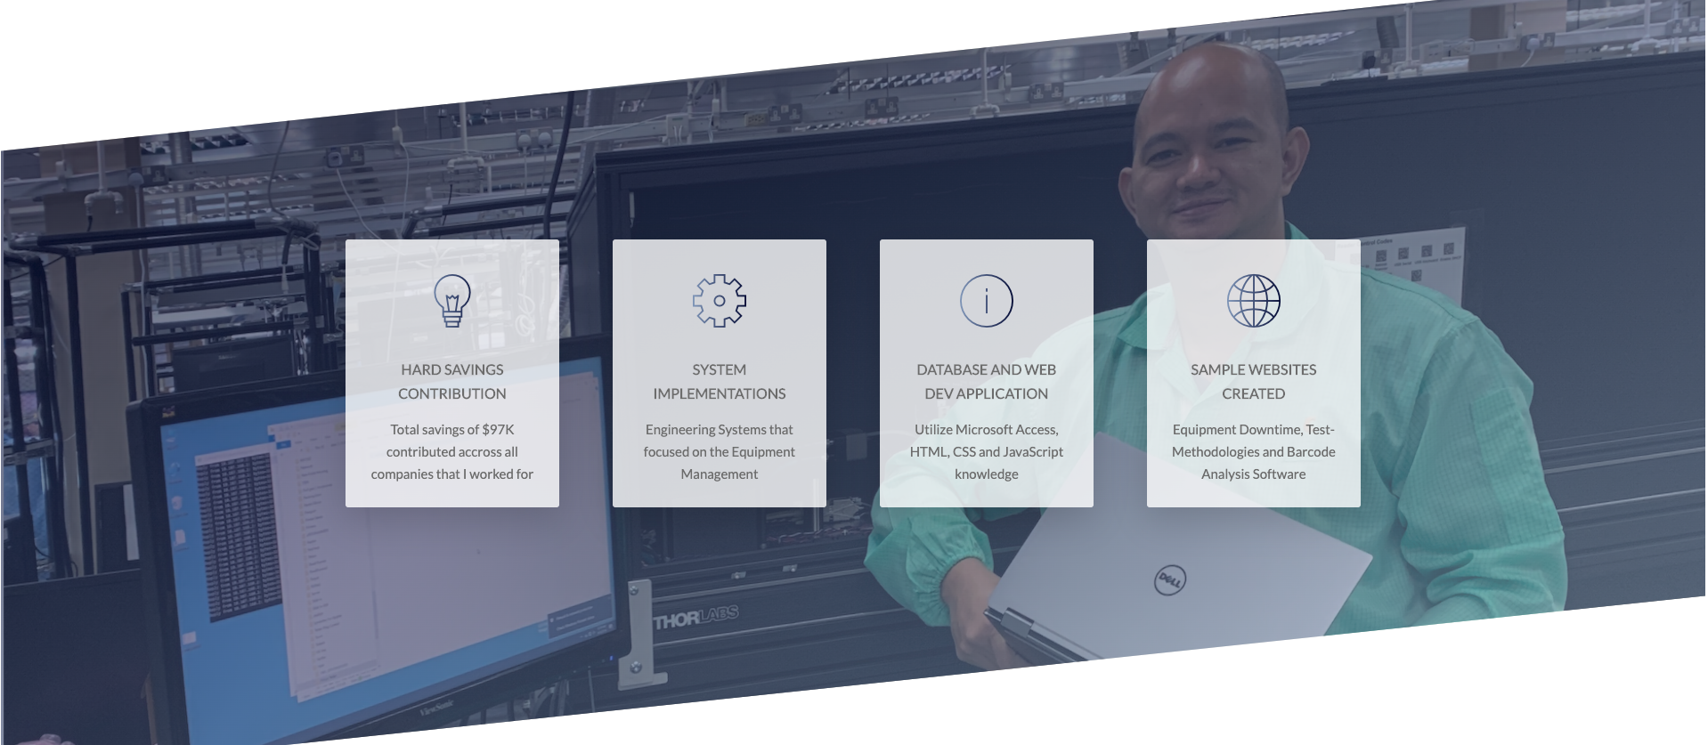

39. Building the Tour Section

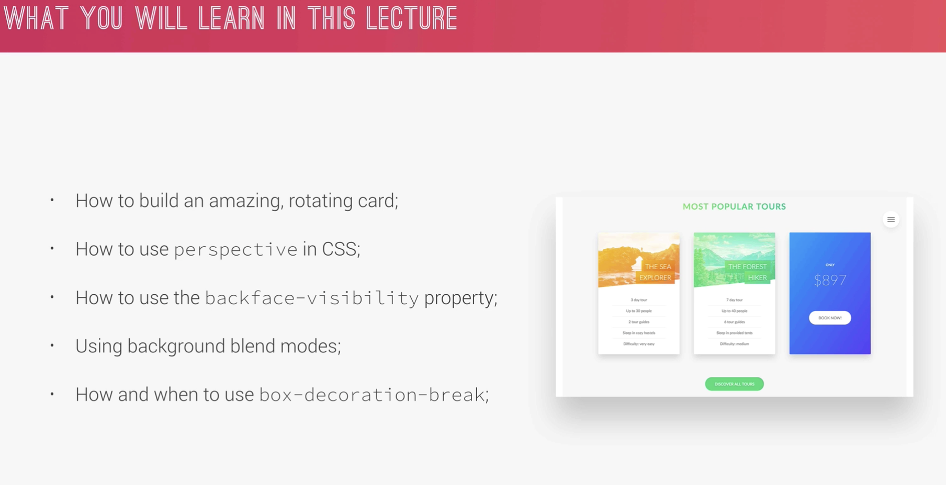

* Use of rotate(180deg), this makes the card to rotate
* Use of perspective
* Use of -moz-perspective, this is to make it work in mozilla
* Use of backface-visibility: hidden, it hides the back part of the element
* Height:50 rem; was assigned in .card to fix the perspective issue during transition. It’s similar to “clearfix” but it’s not applicable to position:absolute. It’s only applicable to float positioning.
* Use of “ease” in transition for smoother effect
* For linear-gradient() should use background-image not background-color.
* 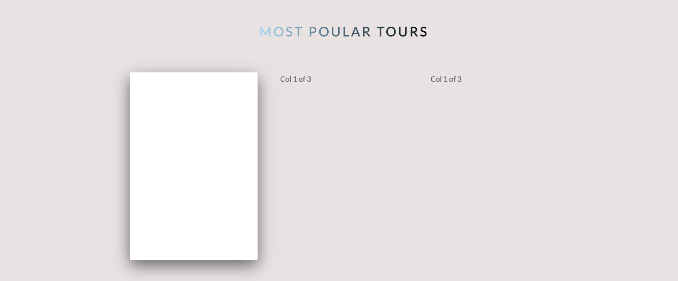
* 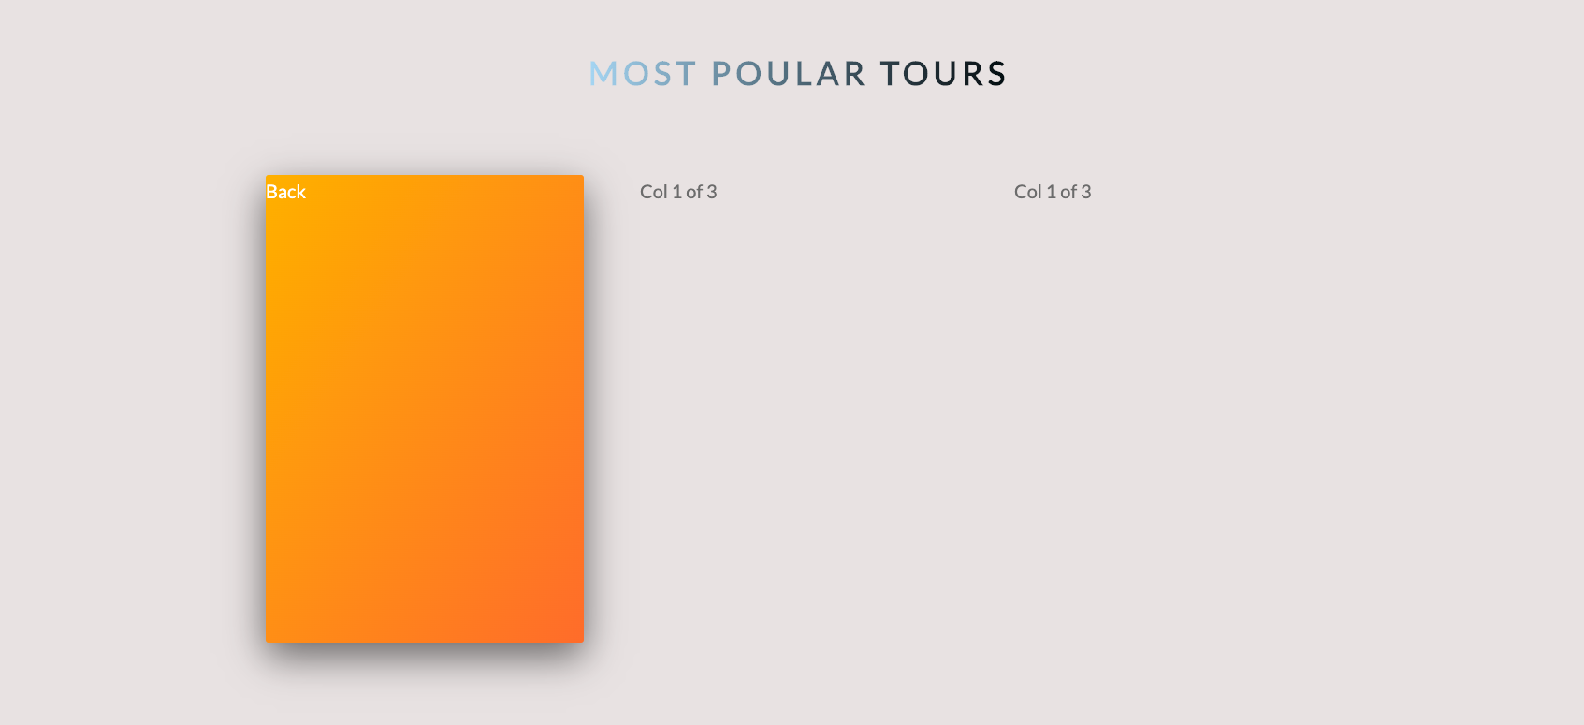

40. Building the Tour Section – Part 2 (_card.scss)

* New feature of css = Background-blend mode – will make the image to blend with a linear-gradient. It seems like a filter
* Overflow: hidden will not make the image to overflow inside the div
* Semantic means we’re using the right html tag for right content
* Use absolute positioning for thr H4 to position it as desired
* Use of span is to wrap around a text
* Use again of margin: auto, to center the text. This will make the browser to auto calculate. 0 = top and bottom, auto = left and right automatically.

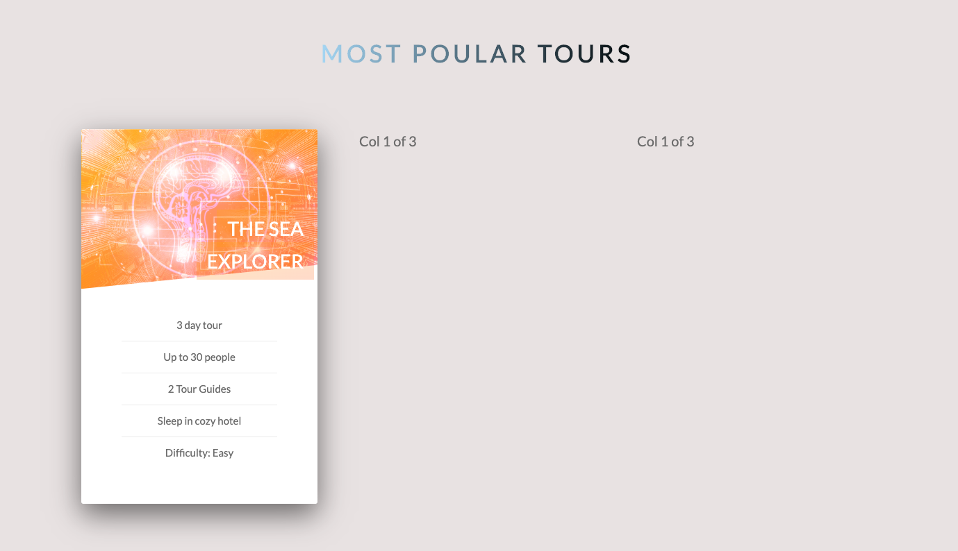

41. Building the Tour Section – Part 3 (_card.scss)

* Setup the html
* Create the new utility u.margin-top-big for the button “Discover all”
* Create the new utility u.margin-top-big for the button “Discover all”